**ALOA**

Electronic

Locking

Solutions

We 're Giving  
Our Guests  
The Very Best.

Insert And Remove

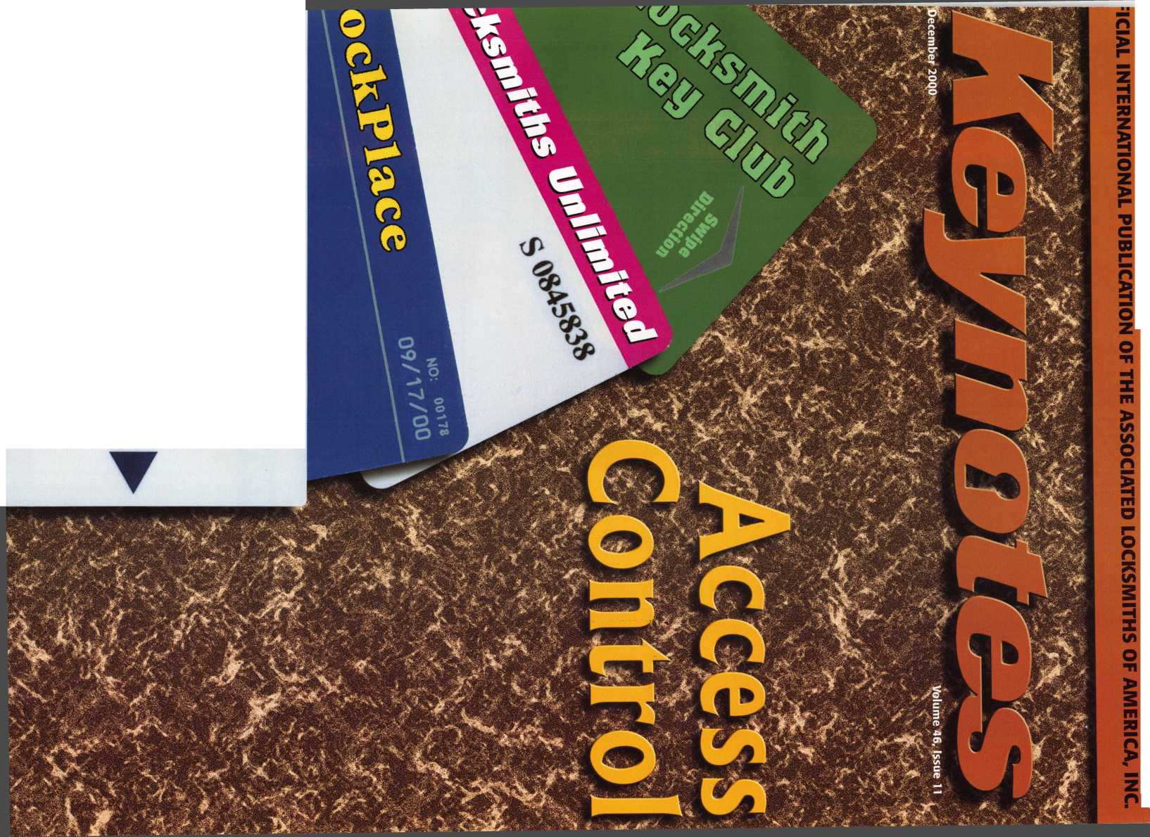

*WM*

*Visit our Website on www. stamcctv. com*

tl Productivity

til System Drawing

|  |  |
| --- | --- |
| W Estimation |  |
| tl CCTV Training | |
| II CCTV Reference | |
| HI Sales/Demo |  |
| tl System Design |  |
| tl Staff Evaluation |  |

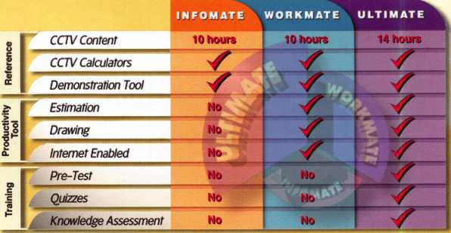

Sold in Over 50 Countries j

Distributed by:

COPYRIGHT © 1996 Security Training and Marketing Pty Ltd. All rights reserved ACN 057 006 541

□ Yes, please send me a FREE PREVIEW CD ROM $9.95 S/H

Name:

Job Title:

Organization:

Zip/Postcode

Country e-mail

Tel: ( ) Fax: ( )

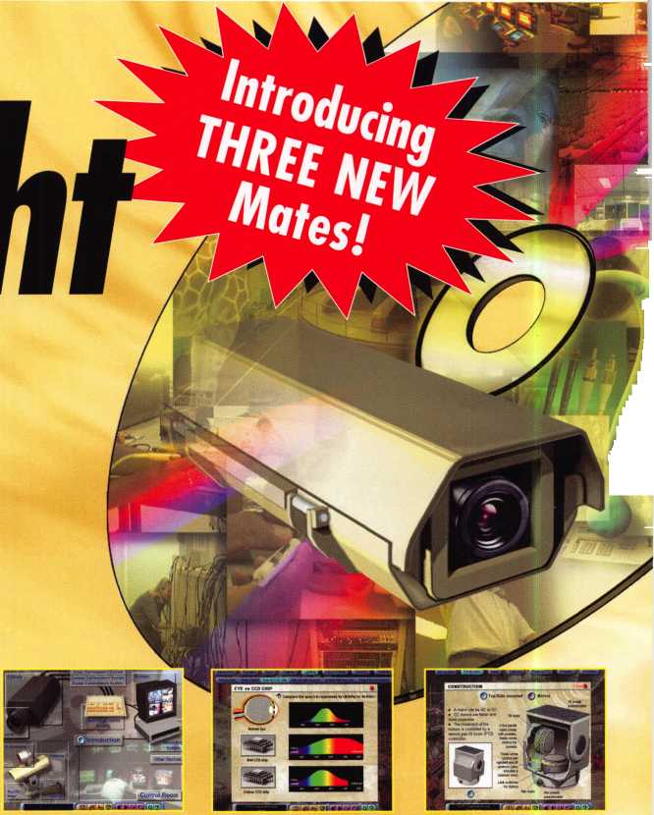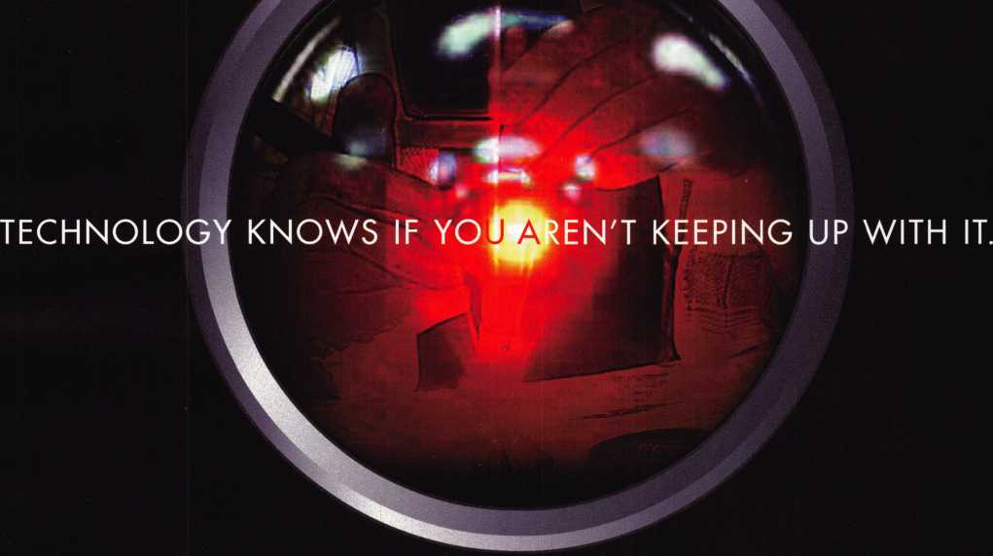

BEFORE ANYONE ELSE FINDS OUT, LOOK INTO SAFETECH 2001

**When professionals don't keep up with the evolution of their industry it shows.**

**It shows in loss of business, of revenue, of customer confidence.**

**Focus on where your professional future is going at SAFETECH 2001 in St. Louis, Missouri.**

**In a city that fires the imagination, you will discover safe technology advances you never imagined possible.  
For more information call 214.827.7233, or email [convention@savta.org](mailto:convention@savta.org).**

**SAFETECH 2001—A Safe Odyssey.**

SAFETECH

**2001**

A SAFE ODYSSEY



**ST. LOUIS, MO**

**Rfinfimhfir**



Contents

Features

4

President’s Journey

14

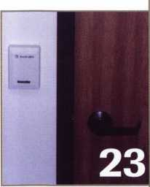

A.L.O.A. Award Recipients

Keynotes profiles this year’s ALOA Award winners, A1 and Jerry Hoffman.

By Mike Emery

16

Where Have All The Mentor’s Gone?

Our author tells what having a mentor meant to him and why it is important for experienced locksmiths to mentor their employees.

By Michael Finn

19

Magnetic Contacts

Get an overview of your choices when it comes to contacts.

By Greg Perry

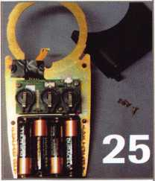

23

A Guide to Card Readers for Access Control Find out more about the card reader technology that’s

available with today’s access control systems.

25

Batteiy Powered Access Control

Are you Electro phobic when it comes to wires and access control? Our author takes a look at the products and capabilities involved with battery powered access control units.

By Sal Dulcamara, CML

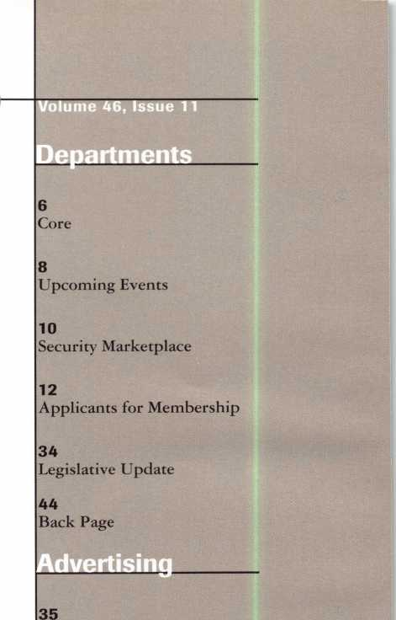

Classifieds

38

Associate Members

42

Ad Index

29

All In The Family

What’s the key to running a successful family business? Take a look at the ups and downs of a family working together.

By Claire L. Cohen, CML

30

Time is Moving On Take a look back in time.

By Don Dennis

33

Art direction/design Phoenix Design **972.479.9026** ConQuest Graphixs **817.285.0003**

ALOA Scholarship Application

Time is running out. Take advantage of the associations most valuable resource, education. Take the time and fill out this application before the February 1 deadline.

|

Keynotes

December 2000



|  |  |
| --- | --- |
| Technical Editor | David Lowell, CML, CMST [david@aloa.org](mailto:david@aloa.org) |
| Managing Editor | Patanya Johnson [editor@aloa.org](mailto:editor@aloa.org) |
| Editorial Advisor | John D. Cannon, CML j dcannon @ worldnet. att. net |
| Advertising Sales | Marvin Diamond  Native American Journal Co. (770) 993-3544 [thediamonds@mindspring.com](mailto:thediamonds@mindspring.com) |
| Contributing Editors | Paul Chandler, CRL  Claire Cohen, CML  Sal Dulcamaro, CML |
| Contributing Authors | Jerome V. Andrews, CML  Brian Costley, CML, CMST  Bob De Weese, CPL  Ray D’Adamo, CML  Michael A. Ferrill  James Glazier, CML  Daniel Graffeo, CRL, CMST Wayne Gurnee, CRL  A.J. Hoffman, CML  Ken Holmlund, CRL  Ray Lusk, CML  Mark Ohno  Randy Simpson, CML  Robert Stafford, CPL  Dave Thielen, CML |
| Executive Director | Charles W. Gibson, Jr., CAE [charlie@aloa.org](mailto:charlie@aloa.org) |
| Operations/Membership Manager | Mary May [mary@aloa.org](mailto:mary@aloa.org) |
| Membership Coordinator | Shelly Jett |
| Mail Room Coordinator | Emmett McCrohan |
| Comptroller | Kathy J. Romo |
| Accounting Coordinator | Kathy Stokes |
| Government Affairs Manager/ Chapters & Regional Associations Liaison | Tim McMullen [tim@aloa.org](mailto:tim@aloa.org) |
| PRP/Education Manager | David Lowell, CML, CMST [david@aloa.org](mailto:david@aloa.org) |
| PRP/Education Coordinator | Ashley Manson |
| Meeting Coordinator | Thom Terry |
| Information Systems Manager | Randy McChristian |
| Network Specialist | Greg Jackson |
| Receptionist | Alin Valdez |

Executive

Additional contact information for the ALOA Board and most Keynotes authors is available through “Locksmith Search’” on the ALOA website- [www.aloa.org](http://www.aloa.org) or by contacting the ALOA office at 3003 Live Oak Street; Dallas, TX 75204; (800)532-2562; FAX (214)827-1810; e-mail [aloa@aloa.org](mailto:aloa@aloa.org).

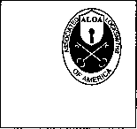

Mission Statement: The Associated Locksmiths of America, Inc. is dedicated to enhancing the professionalism, education and ethics among locksmiths and those in related sectors of the physical security industry. With approximately 10,000 members in the United States, Canada and the freeworld, ALOA is poised to help members obtain the knowledge, the strength, and the confidence to perform their role in the physical security field with pride and dignity. But it is only through active involvement and participation that ALOA can fully achieve its potential-and can help members to achieve theirs.

Policies: Keynoted is the official publication of the Associated Locksmiths of America, Inc. (ALOA). Keynoted acts as a moderator without approving, disapproving, or guaranteeing the validity or accuracy of any data, claim, or opinion appearing under a byline or obtained or quoted from an acknowledged source. The opinions expressed by the authors do not necessarily reflect the official views of ALOA. Also, appearance of advertisements and new products or service information does not constitute an endorsement of products or services featured by the Association. The Association does not accept responsibility for the inaccuracy of any data, claim, or opinion appearing in this publication, due to typographical errors on the part of the authors, Association staff or its agents. Editor’s Note: This publication is designed to provide accurate and authoritative information in regard to the subject matter covered. It is provided and disseminated with the understanding that the publisher is not engaged in rendering legal or other professional services. If legal advice and other expert assistance is required, the services of a competent professional should be sought.

Authors’ Payment: Payment for eligible submissions to Keynotes will be based on the following criteria: topic, time spent and past contributions. Authors who regularly submit to Keynotes are generally paid a higher rate. The latter is especially true of authors who write to fit specific editorial needs and submit said copy by Keynotes deadlines. As a general guideline: Average payment for a 750 word, business or ‘light’ technical article would be $200. Payment for a 1500 word article involving significantly higher time and research efforts would be $400.

Payment will not be offered for articles submitted by ALOA employees or members of the ALOA Board of Directors (unless material is of a technical nature), nor for articles submitted by a company that promote that company’s products or services. ALOA reserves the right not to pay for articles submitted by an individuals) that promote a particular company’s products or services.

Disclaimer: The Associated Locksmiths of America, Inc., (ALOA), reserves the right to refuse any article for any reason. Additionally, ALOA reserves the right to edit, amend or modify any article submitted for publication in order to preserve technical accuracy, clarity, fairness or grammatical correctness. ALOA will make the best efforts to notify the author of any changes. The extent of ALOA’s liability for any article or information contained therein will be a notice of correction or retraction in the next possible issue.

Keynoted (ISSN 0277 0792) is published monthly except for the combined June/July issue by The Associated Locksmiths of America, Inc., 3003 Live Oak St., Dallas, TX 75204-6186. Telephone: (214) 827-1701; FAX (214) 827-1810; e-mail [aloa@aloa.org](mailto:aloa@aloa.org). Subscription rates for members-$15.00 per year. Second class postage paid at Dallas, Texas. POSTMASTER: Send address changes to: Keynotes, 3003 Live Oak St., Dallas, TX 75204-6186. © Copyright 1999, All rights reserved. No part of the contents may be reproduced or reprinted in any form without prior written permission of the publisher.

Board



President

John J. Greenan, CML, CPS (773) 486-2030

Secretaiy

John D. Cannon, CML (703) 960-6413

Directors, Northeast

John C. Magee, III (856) 845-3434 Peter Sarailian, CRL (201) 947-6291 William L. Young, CML (610) 647-5042

Directors, Southeast

Thomas W. Tate (850) 476-4211 Donald E. Rule, CML (601) 324-2658

Directors, North Central

Mark E. Blum, CML, CPS (517) 482-5809 Tom Ripp, CRL (608) 262-3831

Director, South Central

Randy L. Simpson, CML (713) 780-7026

Directors, Southwest

Gordon R. Racine, CML (719) 384-4707 John A. Ilk, CRL (602) 420-2174

Director, Northwest

Scott L. Henke, CRL, CPS (907) 248-3785

Director, Associate Members

David F. Matthies (727) 541-5536

Trustees

Dallas Brooks

(334) 826-8990

David M. Lowell, CML, CMST

(800) 532-2562

Breck H. Camp, CML

(770) 455-6244

Edwin Toepfer, RL

(416) 225-5589

Past Presidents

1997-1999 Dallas C. Brooks 1995-1997 David Lowell, CML, CMST 1993-1995 Breck Camp, CML 1991-1993 Henry Printz, CML 1989-1991 Evelyn Wersonick, CML, CPS 1987-1989 Leonard Passarello, CPL 1985-1987 Joe Jackman, CML 1983-1985 Stanley Haney, CPL 1981-1983 Louis LaGreco, CPL 1979-1981 John Kerr, RL 1977-1979 Clifford Cox, CML 1974-1977 Charles Hetherington 1972-1974 Gene Laughridge 1970-1972 William Dutcher, RL 1968-1970 Constant Maffey, RL 1966-1968 Harold Edelstein, RL 1964-1966 William Meacham 1962-1964 Robert Rackliffe, CPL 1960-1962 Edwin Toepfer, RL 1956-1960 Ernest Johannesen

December 2000

***Keynotes*** | 3

with John J. Greenan

■

PRESIDENT'S JOURNEY

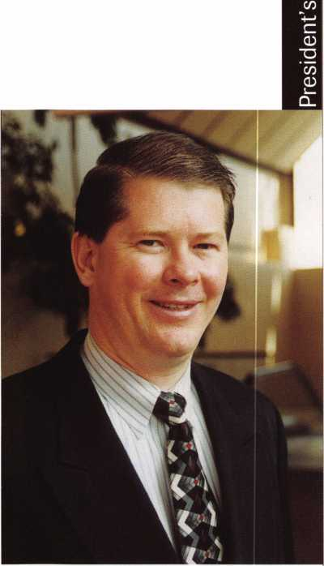

Last month in Chicago, a meeting was held that could have far-reaching effects on all segments of the security industry. The Security Industry Association (SIA) hosted a meeting along with the National Burglar and Fire Alarm Association (NBFAA) and the Central Station Alarm Associa­tion (CSAA), to discuss the merger of their individual associations into one association. Also attending this meeting were representatives from five national alarm companies: ADT, Brinks, SecurityLink, Honeywell and Protection One. Each alarm company expressed the need for a sin­gle industry association to represent the entire electronic security industry.

I have always found it interesting that the alarm industry continues to promote themselves as the electronic security industry. Alarms may provide psychological security but the fact is, alarms monitor a secured area and do not provide any real hardware or electronic security. Locksmiths do provide real security, whether it be mechanical or electronic. We prevent unwanted intrusions, alarms only detect it.

It is important that as locksmiths, we all work together to ensure our interests are protected. That is why last spring, the ALOA Board approved a program for open affiliation between ALOA and state, regional and local locksmith associations, called the Association Affiliate Program. ALOA realizes that these associations are at the heart of our industry. Through strength in num­bers, each group can bring to the affiliation their own resources for the good of the profession overall.

The objectives of this program are to expand membership in locksmith associations, achieve a national affiliation with a strong state association in each of the 50 states for legislative purpos­es, and promote the exchange of ideas and information. There are no fees or dues for membership.

We must all work together towards the goals of the locksmithing industry, which includes elec­tronic access control. In today's world with so many other forces having direct impact on our industry (like the formation of one large association that purports to represent the electronic access control industry), professional locksmiths must combine all their resources to ensure our success in the future. That is why the Association Affiliate Program is an effort to make our col­lective voices heard by government and other related industries, a way to speak on behalf of "the professional locksmith." In order to do that, we need to be prepared when a legislative situation arises. While nothing may be going on in your state at the moment, I assure you it will soon enough. If your local association is not currently an Affiliate member, I urge you to bring up this issue at your next monthly meeting. If you need more information on this program, contact Tim McMullen at the ALOA headquarters (800) 532-2562 Ext 16.

On a completely different note, I would like to congratulate Jim and Alice Taylor of Lexington Kentucky, on their 50th wedding anniversary. Jim has been a member of ALOA since 1956. That was the same year as the first annual trade show and convention held in Chicago, and when Keynotes, was launched. How time flies! Finally, I would also like to take this time to wish every­one a wonderful and joyous Holiday Season. As we rush around to buy gifts and work late hours, let us not forget what this time of the year truly means: family, faith and friends.

John J. Greenan, CML, CPS

41 Keynotes

December 2000



Associated Locksmiths of America

The Brightest

'The

Best.

|  |  |
| --- | --- |
| Robert C Rodocker CRL | 14 |
| James E Gruber CRL | 14 |
| Michael E Jordan Jr, CML | 14 |
| Jon B Griswold CML | 14 |
| James T Brickler CRL | 14 |
| Man S Seo | 14 |
| Joseph C Fuller CPL, CMST | 13 |
| Leonard J Passarello CPL | 13 |
| Frank D Hartung CML | 13 |
| Joseph W Whitaker CPL | 13 |
| Robin A Horsley | 13 |
| Paul M Souber | 13 |
| Donald H Shiles RL | 13 |
| Richard C Sievers | 13 |
| Joe J Lee CRL | 13 |
| Ernest W Wright | 12 |
| Rolando Bouza | 12 |
| Raymond C Lusk CML | 12 |
| John F Engel CRL | 12 |
| Eric F Veal | 12 |
| Basil W Shannon CPL | 11 |
| William J Wickward CML | 11 |
| Calvin G Harris CML | 11 |
| Herbert C Dusenberry CML, CPS | 11 |
| Timothy K Chow | 11 |
| Dale L Knowles CPL | 11 |
| Thomas J Demont CML, AHC | 10 |
| Alvin N Minor | 10 |
| Gene Eldridge CPL | 10 |
| Ronald P Riggins CML | 10 |
| Lester S Brodsky | 10 |
| Larry L Votaw CML | 10 |
| Thomas R Smith CPL | 10 |
| Richard T Johnson CPL | 10 |
| Dale V Crosby CPL | 10 |
| James V Hawley CRL | 10 |

How can I join the President's Club?

You can earn membership in this prestigious dub by recruiting just 10 new members for ALOA.

*Any ALOA member may participate.

What do I get?

When you recruit 10 members, you receive a handsome blue blazer with a President's Club crest. For each additional five members you recruit, you receive a lapel pin with gold-filled numbers, indicating your recruiting successes.

You also get the satisfaction of knowing that you are helping your association, helping your industry grow, and you are helping fellow locksmiths achieve success.

How do I get started?

Contact the ALOA office for a supply of applications (800) 532-ALOA or FAX (214) 827-1810. One President's Club credit is awarded for each new applicant. Credit is awarded only after the membership application is approved. However, the credit will apply for the period in which the application is received. Failure to identify yourself as the sponsor on the application form at the time it is submitted to ALOA for processing will forfeit any credit.

*ALOA Board of Directors not eligible for membership in the President's Club.

|  |  |
| --- | --- |
| Member Name | Number of Sponsorships |
| Kwok-kei Leung | 202 |
| Toshihiro Asano | 108 |
| Henry W Raymond | 93 |
| Yuriko Yanai | 68 |
| Mary S Ohmit CPL | 66 |
| Charles C Robertson CML | ' 65 |
| Jack Hobin CPL | 51 |
| William B Neff CML | 43 |
| Salvatore J Dulcamaro CML | 40 |
| Myeong-Rae Cho | 38 |
| Dana L Barnum CML | 35 |
| Barry K Leas CRL | 35 |
| Danny W Rudd CPL | 31 |
| Larry A Wamick CML | 31 |
| Jeanne G Lodge CML | 31 |
| C Allan Halverson | 29 |
| Anthony J Ramunno CML, CPS | 26 |
| James M Watt CML, CPS | 26 |
| Jeffrey S Nunberg CML, CMST | 26 |
| J Thomas Hood CML | 26 |
| Jim Williams CRL | 26 |
| Lawrence F Smith Jr, CML | 25 |
| James H Glazier Sr, CML | 25 |
| Robert H Stafford CPL | 25 |
| William Lee | 25 |
| John C Elliott Jr, CML | 24 |
| Jerome L Cohen CML | 23 |
| Peter K Gauthier CPL, CPS | 23 |
| Robert F Carroll CPL | 23 |
| Robert D DeWeese CML | 23 |
| Marian M Swann CRL | 22 |
| Diana R Barnum CRL | 22 |
| Elvis D Hammerschmidt CPL | 22 |
| James J Cawby CML, CPS | 21 |
| Eugene R Altobella Sr | 21 |
| John L Shandy CML | 19 |
| Hans Mejlshede CML | 19 |
| John S Dorsey CML | 19 |
| D Michael Lee Sr, CPL | 18 |
| James E Fowler Sr, CML | 18 |
| David C Harris CML | 18 |
| Philip A Rovenolt CPL | 18 |
| Peter R Hall | 17 |
| Thomas G Vandersteen CML, CPS | 17 |
| William P Grant CRL | 17 |
| Keizo Takahashi CRL | 17 |
| Evelyn V Wersonick CML, CPS | 16 |
| Joseph P Ferrero CML | 16 |
| Gary F Teams CPL | 16 |
| Robert W Duman Sr, CML | 16 |
| Michael D Robinson CRL | 16 |
| Brian J Reetz | 16 |
| Maurice Benson | 16 |
| Walter W Lascar RL | 15 |
| William J McElheney CML | 15 |
| Russell P Fuller CRL | 15 |
| Michael B Groves | 15 |
| Daniel L Landry Jr | 15 |

December 2000

Keynotes

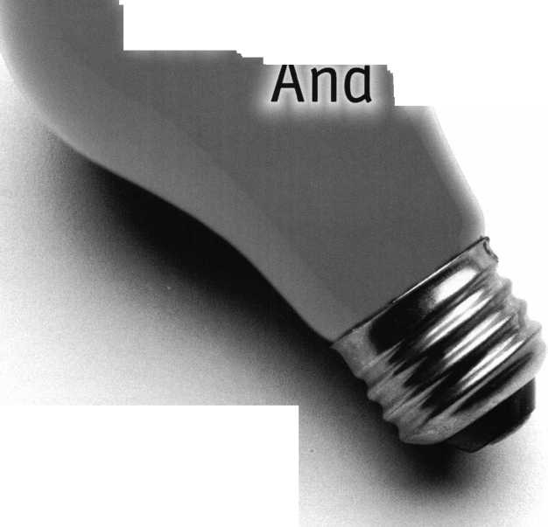

•Congratulations to the Honorees of GPLA’s 50+1 Banquet

The Greater Philadelphia Locksmith Association

held it’s 51st convention and dinner banquet in September. This was a long awaited event after the cancellation of the event in 1999 due to severe weather. The most prestigious award, the Philadelphia Award, was presented to Steve Young. This award is presented annually to an individual who has made the commitment to the craft by showing leadership and inspiration to others, shares their talents, is active in industry associations and has designed or manufactured items that have improved the profession. The Herman Henssler, Jr Award was presented to Nelson Dayton. This award is reserved for members of GPLA who have made exceptional contributions to the growth of the association. This award was named for a founder of both ALOA and GPLA. The Gerald J Connelly, Jr Pioneer Award Recipient was Jay Long. This award is presented to a firm and or individual for their innovative contributions to the craft in the categories of leadership and education. The Lee Rognon Award is sponsored by the Philadelphia Forum and was presented to Dallas Brooks for fostering cooperation among the associations. The Distinguished Distributor Award was presented to Don Amole for his service to the industry and the Industry Award was present to Meilink Safe Company for their unusual contribution to the growth and stature of the craft.

•BRIEFS

Unican on the Market

Aaron Fish, founder-chairman, made a decision back in September to seek a buyer for his company Unican Security Systems Inc. Within a month potential bidders were found and a deal should be made by year-end. The leading contenders are Assa Abloy AB, Kaba SA and Ingersoll Rand.

New Security Company



Camelot Information Technologies, an international technology company located in Haifa, Israel announces the opening of its North American headquarters in New York City. The company’s first line of products is expected to launch in January 2001. This new line of products will be a security solution. This solution is said to be at least two years ahead of the security market.

Keynotes December 2000

**n n rft**

Lockmasters’ Training Now on GSA Schedule

Lockmasters Security Institute’s Training is available through the GSA Schedule. Lockmasters was awarded a five year contract for Instructor-Led Training and Development for Course Materials, Schedule #69. If you have questions, please call (800) 654-0637 ext. 200.

Blick USA, Inc. to Market Security Products

Blick pic, a global provider of security, communication and time management solutions announces the establishment of Blick USA, Inc., a wholly owned subsidiary. Blick USA will provide a range of security, communication and time management products to dealers and distributors throughout the USA. Blick is launching two new access control brands: PAC™, an integrated enterprise class solution; MyEasinet™, a simple yet powerful network system. For more information, please contact Blick USA at (800) 414-3038 or (831) 646-6464.

•REGIONS

The GPLA Holiday Party will be on Friday, December 15, 2000 at the Woodbine Inn on Route 73 in Pennsauken, New Jersey from 7:00 pm-11:00 pm. For ticket sales or more information call Mary Arnold at (856) 665-0464 or (856) 665-1311 or Bob Mock at ((856) 863-0710.

You are invited to take the challenge at the Texas Safe Penetration Party conducted by Keith Knott, CPS on December 15-16, 2000 at 8425 W St. Hwy 29, Llano, TX. Bring your drill rigs and scopes and join some of the best safecrackers in the country. For more information contact Keith Knott at (915) 247-3687.

Did you know that ALOA has over 33 chapters

and 12 affiliate members?

If you would like to participate more directly with the association’s activities or if you would just like to network with other industry professionals, attend a local chapter meeting. The following is a list of the ALOA Chapters. For more information sign on to the ALOA website [www.aloa.org](http://www.aloa.org)

Alabama Locksmith Association Grand Canyon Chapter LA/Orange County Chapter San Diego Chapter Colorado Front Rang Chapter Nutmeg Chapter

Locksmiths Assn of Washington D.C.

European Chapter of ALOA

South Florida Chapter

Georgia Chapter

Central Indiana Chapter

Northern Indiana Chapter

Southern Indiana Chapter

Japan Chapter

Korea Chapter

Kyana Chapter

Massachusetts Chapter

Chesapeake Chapter

Minnesota Chapter

Montana Chapter

Northern Prairie Chapter

Nebraska Chapter

Garden State Chapter

New Mexico Chapter

Sun Belt Chapter

Ohio North Coast Chapter

Ohio Valley Chapter

Keystone Chapter

South Dakota Chapter

West Tennessee Chapter

Fox Valley Chapter

Wisconsin Indianhead Chapter

Wyoming Chapter

ASSOCIATION AFFILIATE MEMBERS

California Locksmith Association National Locksmith Assn of Canada Central Florida Locksmith Association Institutional Locksmith’s Association Gateway Locksmithing Association Missouri-Kansas Locksmith Association Pacific Locksmith Association Central Pennsylvania Locksmith Association Greater Philadelphia Locksmith Association Greater Dallas Locksmith Association Greater Houston Locksmiths’ Association

•EXECS

Lockmasters, Inc., is proud to  
announce the addition of Tom  
Seroogy of Selma, Alabama to  
the Tool and Equipment  
Division. Joining the team of  
sales representatives, Seroogy  
brings with him an extensive  
background in locksmithing  
and sales, including former sales  
positions with BWD  
Automotive and Strattec, Inc.

He is the former managing editor of The National Locksmith  
magazine, director of The National Locksmith Automobile  
Association (NLAA), and director of Crime Prevention  
magazine. Seroogy owned American Locksmith & Alarm,  
Inc., specializing in automotive locksmithing and access  
control. Seroogy is also an ACE instructor.

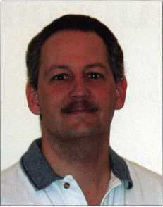

Tom Seroogy

Black & Decker Corp has promoted Christopher T. Metz to president, North American Hardware and Home Improvement (HHI). This is a newly created position and he will be responsible for implementing the integration of the various HHI functional areas. Metz will continue to be president of Kwickset Corp.

Blick USA, Inc. is pleased to announce that two industry veterans have joined it’s executive management team. Steve Rogers, senior vice president, sales and Drew Chernoy, vice president, Marketing/Operations.

Rogers will be responsible for the strategic direction as well as managing the sales activities. Chernoy will be responsible for marketing strategy and planning as well as managing operational activities.

•PRP

ALOA is offering PRP/STPRP testing every second Friday of the month at the ALOA Headquarters. We are located at 3003 Live Oak Street, Dallas, Texas. For more information on testing contact Ashley Manson at (214) 827-1701 X30. ALOA would like to congratulate the following individuals who have recently achieved PRP designations.

CRL

Calder, Robert, Leadville, CO Caufman, Daniel K., Wellington, CO Cunningham, Daniel E., Camas, WA Huddleston, Brian E., Lajunta, CO Skelley, Wayne D., Laramie, WY

December 2000

Keynotes

Upcoming

Events



Dept

**\p\** Indicates ALOA ACE Class **ft** Indicates PRP Sitting

DECEMBER

3

**ft** ALOA PRP Sitting Dalton, GA

Contact: Stephen Gebbia, CML (770)455-6242

8

**ffr** ALOA PRP Sitting Dallas, TX

Contact: Ashley Manson (214)827-1701 (214) 827-1810 fax

9

Holiday Celebration 2000 San Diego, CA

San Diego Chapters of ALOA & CLA Contact: Dan Bozarth (858)271-1155

2001

JANUARY

17

Mag Installation Evening Seminar

Milwaukee, WI

Clark/ Fox Valley Chapter

FEBRUARY

3

Ace Classes

Electronic Safe Lock Class Alabama Locksmith Association Contact: Dallas Brooks (334) 826-8990

3-4

West Coast Lock Collectors Show Arcadia, CA

West Coast Lock Collectors Contact: Bob Heilemann (310) 230-3004 evenings (310) 454-7295 message

6-11

**ft** ALOA PRP Sitting  
Ace Classes (12)

2001 Annual Convention &

Trade Show Austin, TX

Omni Austin Hotel Southpark The Texas Locksmiths Association Contact:

Registration:

Jim Hetchler (380) 606-1727 Exhibits:

Robert Hernandez (210) 433-5397 General info:

Judy Clifford (979) 297-2413

8

**ft** ALOA PRP Sitting Dallas, TX

Contact: Ashley Manson (214)827-1701 (214) 827-1810 fax

MARCH

9

**ft** ALOA PRP Sitting Dallas, TX

Contact: Ashley Manson (214)827-1701 (214) 827-1810 fax

23-25

ALOA Spring Board Meeting Dallas, TX

28-April 1

MLANJ 2001 Annual Convention **fcrv** Ace Classes (17) **ft** PRP Sitting Somerset, NJ Convention Contact:

(973) 267-8884 (973) 538-2248 fax [www.mlanj.org](http://www.mlanj.org) PRP Contact:

Dan McGlynn, CML (732) 634-4605

April

i

**ft** ALOA PRP Sitting Rosemont, IL Clark Security Products Contact: Joan Emrick (619)718-7308

4-6

ISC Expo/ West 2001 Las Vegas, NV

Sands Expo & Convention Center

13

**ft** ALOA PRP Sitting Dallas, TX

Contact: Ashley Manson (214)827-1701 (214) 827-1810 fax

14

**ft** ALOA PRP Sitting White Bear Lake, MI Minnesota Chapter of ALOA Contact: Alan Morgan (763) 566-2637

30-May 5

SAFETECH 2001 St. Louis, MO (214) 827-7233

MAY

10-12

**ft** ALOA PRP Sitting

IDN 2001 Trade Show & Security

Conference

Ypsilanti, MI

Contact: Fred Strasberger

(800)521-0955 or

Bonnie Weston

(734)591-1150

11

**ft** ALOA PRP Sitting Dallas, TX

Contact: Ashley Manson (214)827-1701 (214) 827-1810 fax

JUNE

8

**ft** ALOA PRP Sitting Dallas, TX

Contact: Ashley Manson (214)827-1701 (214) 827-1810 fax

JULY

13

**ft** ALOA PRP Sitting Dallas, TX

Contact: Ashley Manson (214)827-1701 (214) 827-1810 fax

15-22

ALOA 2001 Security Expo Baltimore, MD (800)532-2562

AUGUST

10

**ft** ALOA PRP Sitting Dallas, TX

Contact: Ashley Manson (214)827-1701 (214) 827-1810 fax

SEPTEMBER

14

**ft** ALOA PRP Sitting Dallas, TX

Contact: Ashley Manson (214)827-1701 (214) 827-1810 fax

OCTOBER

12

**ft** ALOA PRP Sitting Dallas, TX

Contact: Ashley Manson (214) 827-1701 (214) 827-1810 fax

15-21

Tri Regional Locksmith Conference Portland, OR

Pacific Locksmith Association Contact: Stan Hauer (503) 325-7334 Email [hauer@pacifier.com](mailto:hauer@pacifier.com) Contact: Ken Mead (503) 873-6932

NOVEMBER

9

**ft** ALOA PRP Sitting Dallas, TX

Contact: Ashley Manson (214)827-1701 (214) 827-1810 fax

DECEMBER

14

**ft** ALOA PRP Sitting Dallas, TX

Contact: Ashley Manson (214)827-1701 (214) 827-1810 fax

2002

**JULY**

22-28

ALOA 2002 Security Expo Rosemont, IL (800)532-256

Keynotes

December 2000

2001

Editorial Calendar

January

Door Hardware

February

Padlocks

Business Management  
Product Showcase

March

Computers/Electronics  
Master Keying

April

Institutional Locksmithing

May

Safes

June

High Security

July/Aug

New Products

ALOA Security Expo Preview

September

ALOA 2001 Coverage  
Tools

October

Crime Prevention  
Product Showcase

November

Automotive

Oecember

Access Control  
Computers Electronics  
Nostalgia/History

SECURiTys

LOCK COMPANY HP

**New** Factory Replacement Parts and Locks for Security Corporation and Kumahira Safe Co. Products

* Safe Deposit Box Locks and Parts BX, KD
* Automatic Remote Tube Systems (ARTS)
* Drive Up Systems
* Vault Doors
* Night Depositories
* Camera Systems
* Key Blanks and
* Keys Cut to Code

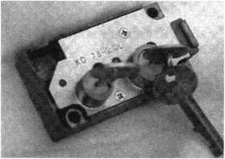

KD Series

Safe Deposit Box Locks

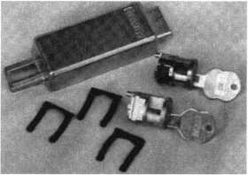

BX Series Safe Deposit Locks

1155 Chess Drive, #114 Foster City, CA 94404 Phone: (650)525-0660 Fax: (650) 525-0444

Email:

[chaslutz@securitylockco.com](mailto:chaslutz@securitylockco.com)



SECURITy

LOCK COMPANY

December 2000

Keynotes 9

Security

Marketplace

Adams Rite Manufacturing

Adams Rite Manufacturing Company recently introduced the 3900 Series fire-rated exit device for wood doors.

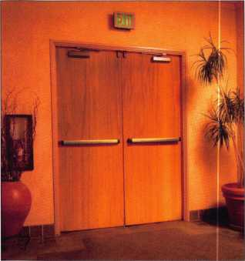

The 3900 Series has a full fire-rated Warnock Hersey listing for up to 90 minutes with 8’0” x 8’0” pairs and 4’0” x 8’0” single doors. It has a smooth quiet operation and fully meets ADA guidelines. The 3900 Series is intended for single doors, double egress and same swing pairs. Adams Kite

151 N Kraemer Blvd #100 Placentia, CA 92870 (714) 993-0898 (714) 993-6337 fax

Sanyo

Sanyo Security Products Division introduces the VMC-8613 high- resolution color 13’’(diagonal) monitor and the VMC-8618 high-resolution color 18”(diagonal) monitor for Industrial/Commercial security applications. The VMC-8613 offers over 750 lines of resolution and the VMC-8618 offers over 800 lines, both in a chassis that can be mounted in a standard rack. Model VMC-8618 includes an Over/Under Scan Switch to make viewing easier. This feature allows the operator to view the picture

,L Keynotes December 2000

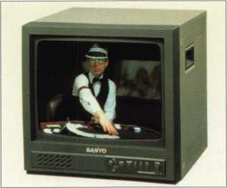

on the entire physical screen of the monitor. Additional features of the VMC-8613 and VMC-8618 are dual video inputs with selectable composite and S-video, built-in audio with loudspeaker control and an automatic voltage selector.

Sanyo Security Products Division 21605 Plummer St Chatsworth, CA 91311 (818) 998-7322 (818) 701-4182 fax

Medeco®

Medeco® introduces the Embassy® Classroom Security function lockset to meet the increased demands for quality high-security products for schools. Unlike the typical classroom function lock, the Medeco Classroom Security function lever lockset allows teachers to lock the outside lever from

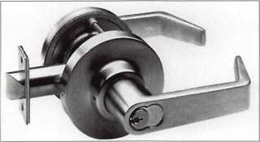

the inside and deny access to an unwanted intruder. At the same time, it allows those within the classroom to exit at all times to protect safety and life. The lockset exceeds ANSI Grade 1 operational and security requirements. In

addition, it can only be locked by key. The lockset is available in all trim designs and finishes. It also offers key-in-lever cylinders and inter­changeable cores that can be keyed into an existing Medeco key system. Medeco® High Security Locks (800) 839-3157

Alarm Lock

Alarm Lock introduces the Trilogy Prox Lock PDL3000. The Prox Lock is a proximity/digital, standalone single door access lock with Audit Trail.

This lock offers the combination of a proximity lock and a digital lock all in

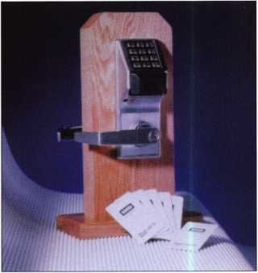

one. The Prox Lock accepts most HID proximity cards and keyfobs, including the 26, 33 and 37 bit, etc. The lock is programmable with up to 2000 User codes. Users can be programmed in three ways: card only, code only or both card and code. The keypad also locks out after numerous attempts to “guess” codes. Another feature is the Audit Trail, which can hold up to 40,000 events, with printed time/date-stamped log of all electronic activity. The Prox Lock also has a real time clock which enables 500 scheduled events and holiday schedules.

Alarm Lock Systems Inc.

(800) 645-9445 ext. 64

Dortronics

Dortronics has begun shipping of its series of power supplies employing advanced features and door control/ alarm systems integration capabilities. The 4200 Series Power Suppliers offer field selectable 12 or 24 VDC operation and integrate a fire alarm

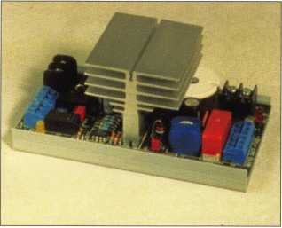

release, alarm output relays and low battery notification functions. Models are available in 2 and 4 amp versions to accommodate various door lock and alarm applications. The suppliers are available in two models: the 4202 Power Supply features a 2 amp output designed for single and double electronic door lock installations. The 4204 Power Supply offers a 4 amp output for installations with multiple door locks and additional security devices. Both units offer field selectable 12 or 24 VDC output for use with any electronic security device. Unlike other power supplies, Dortronics’ 4200 Series operates at the exact voltage required even when loaded beyond their maximum rated output. The power supplies feature a unique fail-safe fire alarm relay to assure the release of an on-board fire alarm relay and to detect ground faults in wiring to the fire alarm panel. Also unique is the ability to connect several 4200 Series Power Supplies to a single fire alarm panel output. Additional features include: total electrical protection with fused 110 VAC and DC circuits; a built-in charging circuit to maintain optimum battery power; and LED indicators to provide visual confirmation of power and battery status.

Dortronics Systems, Inc.

(800) 906-0137 sales @ dortronics. com www. dortronics. com

Schlage

Schlage expands its lineup of key control products with the Everest family of patented key ways. The Everest cylinder is designed to accept only an Everest key, and the Everest key has a patented undercut groove to prevent unauthorized key duplication. Everest keys can only be copied by Schlage authorized locksmiths. Everest fills the niche between Schlage’s Classic and Primus® product offerings. It is easy to upgrade to Everest by changing existing cylinders to Everest cylinders.

Schlage

Ingersoll-Rand Commercial Security & Safety [www.irco.com](http://www.irco.com)

Illinois Lock Company

Illinois Lock Company announces their UL®/NEMA® tested weather resistant series of locks. These locks withstand harsh environments with stainless steel key way/dust shutters, bezels, triple layered plating and internal “O’Tings, and are manufac­tured to operate after 500 hours of salt spray testing. All of the locks are available in both standard and weather resistant designs.

Illinois Lock Company

301 West Hintz Road

Wheeling, 1L 60090

(847)537-1800

(847) 537-1881 fax

[sales@illinoislock.com](mailto:sales@illinoislock.com)

[engineering@illinoislock.com](mailto:engineering@illinoislock.com)

Yale Security Group

Corbin Russwin (member of Yale- Corbin U.S. and owned by ASSA ABLOY Group), has announced the receipt of an U.S. Patent No.

6,125,674 for it’s new Pyramid cylinder. Pyramid is a secure locking system in the commercial hardware locking industry. Its cylinders provide a high level of security by utilizing a patented locking mechanism in the cylinder that must be depressed by a control pin in the key for the cylinder to be activated. Pyramid is recom­mended for installations requiring superior protection against picking,

drilling and other surreptitious entry. Patented cylinders provide protection against unauthorized key duplication through key blank distribution guidelines. Pyramid’s patent is valid until 2018.

Yale Security Group 1902 Airport Rd Monroe, NC 28110 (704) 226-6104 (704) 226-6154 fax

Panasonic Security Systems

Panasonic Security Systems Group has announced the appointment of three new sales represenatives to handle the company’s line of CCTV systems products. The appointments include Pacnor Marketing, Inc. in Mukilteo, WA; TJB Sales, Inc. in Grayson, GA and Summit Sales & Marketing in Des Moines, IA.

Pacnor Marketing will be responsible for sales activity in the Northern California territory, the state of Nevada excluding Clark County, the Pacific Northwest territory including Alaska, Oregon and Washington, and the western portion of Idaho and Montana. They can be reached at 11524 Mukilteo Speedway, Suite 101, Mukilteo, Wa. 98275, phone (800) 347-1266, fax(425) 315-8727.

TJB Sales will be responsible for sales activity in North Carolina, South Carolina, Georgia, Alabama and Florida panhandle. They can be reached at 1334 Gulfport Run, Grayson, Georgia 30017, phone (770) 449-0999, fax (770) 449-7901.

Summit Sales & Marketing will be responsible for sales in Kansas, Nebraska, Iowa, Missouri and the southern counties of Illinois. They can be reached at 3839 Merle Road #275, Des Moinoes, Iowa 50310, phone (515) 253-0738, fax (515) 253-0842. Panasonic Security Systems Group (877) 733-3689 cctv.panasonic. com

December 2000

Keynotes

Applicants

For Membership

Dept

***r***

***The following applicants are scheduled for clearance as members  
ALOA. The names are published for member review and comment***

***prior to January 1,2001, respectively, to ensure applicants meet standards of  
ALOA’s Code of Ethics. Protests, if any, should be addressed to the  
Membership Department and must be signed.*** ^

COLORADO Steamboat Springs

Russ W Ortiz SPONSOR: Brian Thomas

CONNECTICUT

Meriden

Chester A Dumont CRL

FLORIDA Boca Raton

Larry P Windcoor SPONSOR: Mel Roseman

Jacksonville

Charles R Walther

Tampa

David A Hickmon Sr SPONSOR: Terry Rex

GEORGIA

Atlanta

Willie J Durante SPONSOR: Michael Dorn

HAWAII

Honolulu

Rodolfo B David

MAINE

Litchfield

Carrie C Robichaud SPONSOR: Maurice Robichaud

MARYLAND Ellicott City

James J Noonan SPONSOR: Robert Sieveking

MASSACHUSETTS

Fitchburg

Franklin O Reffitt SPONSOR: Chris Cunha

Needham

Michael Sullivan SPONSOR: Joe Page

South Grafton

Eric S Gregoire SPONSOR: George Doetzl

MICHIGAN

Richmond

John M Taft

SPONSOR: Alan Halverson

Saginaw

Robert E Lamont

Shepherd

Nathan Ettinger SPONSOR: William Lockwood

NORTH CAROLINA

Asheville

John M Przyblo

Fuquay Varina

Joel A Dickson SPONSOR: Adrian Busse

Lincolnton

Johnny A Hefner SPONSOR: Walter Shrum

NEVADA

Henderson

Endre Mills

SPONSOR: Eugene Altobella

Las Vegas

Thomas C Sparks SPONSOR: Eugene Altobella

NEW HAMPSHIRE

Haverhill

Lawrence M Sedgwick Jr

NEW JERSEY New Brunswick

James S Skinner SPONSOR: Teri Lesto-Skinner

North Brunswick

Edward C Simon SPONSOR: Teri Lesto-Skinner

Lexine Skinner-Simon SPONSOR: Teri Lesto-Skinner

NEW MEXICO Roswell

Perry C Gipson SPONSOR: Allen Dwyer

NEW YORK Katonah

Barton P Tyler SPONSOR: Robert Madsen

Patchogue

Lonnie H Ringe

OHIO

Fremont

John T Sharpe

PENNSYLVANIA West Chester

Peter J Bagnall SPONSOR: Ron Blevins

SOUTH CAROLINA

Laurens

George F Henderson SPONSOR: Phil Ashley

SOUTH DAKOTA

Watertown

Victor D Routh Sr SPONSOR: Kenneth Stemig

TENNESSEE

Memphis

Joseph Douglas

TEXAS

Austin

Steven A Tycer SPONSOR: Jim Hancock

Carrollton

Tom L Loftis

VERMONT North Ferrisburg

Martha Y Kenfield SPONSOR: George Gardner

WASHINGTON

Ellensburg

Lee Fisher

WISCONSIN

Mauston

John W Atkins SPONSOR: William J. Smith

CANADA

PQ

St Laurent

Darren A Berendt SPONSOR: KenOutram

JAPAN

Kasukabe Saitama

Nagao Morimoto SPONSOR: Unisuga Satoshi

THAILAND

Yannawa Bangkok

Kiti Thengtrirat

YUGOSLAVIA

Belgrade/Zemun

Pavle Ristic

Keynotes

December 2000



“If you want to study for the CPS test,

you need this book.

Without that book, I wouldn't have my certification.”

-Dennis Johnson, CML, CPS  
Aurora, Illinois

"Mike's new book is very  
consistent with the study  
information required to pass the  
SAVTA/ALOA CPS certification  
test I wouldn't have passed  
without it A tremendous  
resource for today  
and tomorrow..."

-John T. Grist, CML, CPS  
North Georgia Security

"The Safe Technicians Reference Manual by Mike Oehlert ranks among the best technical reference and learning aids you will find in the safe and vault industry. It contains page after page of essential information and easily understood illustrations. Besides answering most of the questions commonly asked by technicians new to the field, Mike has also included plenty of information experienced technicians will find useful."

-Ken Dunckel Pacifica, California

—►Over 600 Illustrations.-*—

320 pages. Only $135.

What are you waiting for?

To order, call 800-532-2562. Allow 3 weeks for delivery.

All major credit cards accepted; or make check payable to ALOA.

December 2000 Keynotes L

The Safe

Technicians  
Reference Manual

First Edition

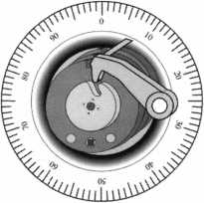

By Mike Emery

(Special thanks to Peter H. Field, RL for contributing to this story).

Keynotes

ALOA's Lifetime Of Achievement Award is a  
regular highlight of the association's  
annual convention. Speculation as to  
who the winner will be is usually  
quite high by the time the

banquet rolls around. After all,  
past winners have included  
such industry luminaries as  
former ALOA President

Stanley Haney in 1997,

Harold (Hal) Tibbits in  
1998 and last year's  
winner Peter Field.

As indicated by its  
name, it's the  
association's way of  
recognizing those who  
have risen above the  
normal call of duty  
and played a vital role  
in the security industry.

Candidates are typically  
those who have donated  
time and energy to  
national, state and local  
associations. Or perhaps  
those who have focused their  
energies on the educational

aspects of the industry. Also, it's an  
award designed for individuals who  
have gone to great lengths to help the  
industry rise to great heights.

All of the aforementioned names have done exactly that  
and this year's recipients (yes, there were TWO winners  
this year) are no exception. Receiving the A.L.O.A. Award  
this year were none other than the brotherly duo of

A1 and Jerry Hoffman.

Of course, it's rare that two people win

the A.L.O.A. Award in tandem, but in  
this case, it's difficult not to view  
the brothers' joint efforts as  
being one.

Before one can examine the  
accomplishments of both  
men, it's necessary to  
review their extensive  
roots in this business.

To do that, one must

look at the man who

introduced them to

this industry, their

father Harold

Hoffman.

Harold ran a  
business on the  
south side of  
Chicago in the 1920s.  
A fix-it-shop of sorts,  
the elder Hoffman  
specialized in repairing  
small, everyday items as

well as cutting keys.

By the end of the decade, he  
and wife Frieda headed to the  
north side of town where business

was a little more profitable.

With a wife and son A1 to support,

Harold's mind for business was always in mode.  
Just as he had cleverly moved the business to another  
part of town, he soon decided that it was time to change  
the direction of the overall venture.

December 2000

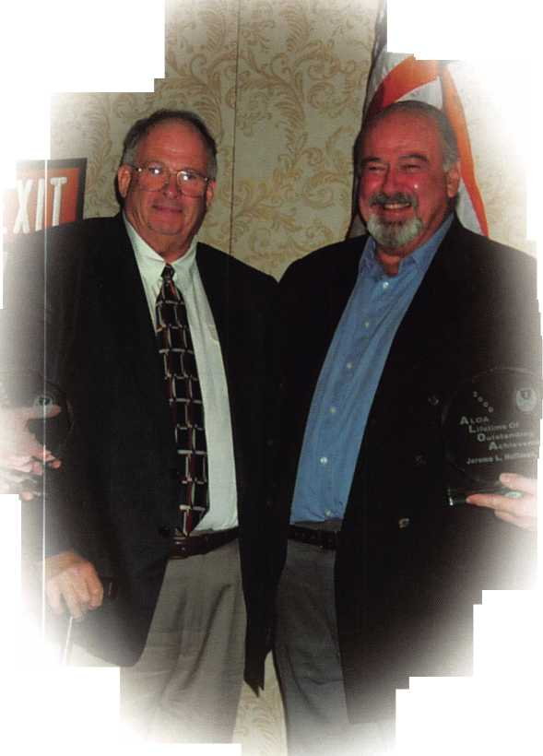

With A1 already working in the store at a young age, Harold Hoffman began plans to alter the business in a way that would allow it to grow with the industry.

By the '30s, Harold and Frieda were blessed with another son Jerry. Despite the Great Depression, he changed business directions. His retail shop was prospering and his wholesaling days were just beginning. His experience in the field allowed him to become a creative force in the invention of the first mass-produced lock picks.

As World War II escalated in the 1940s, Hoffman lost nearly all of his retail employees to the draft. Forced to shut down the shop, he focused all of his energies on wholesale and manufacturing.

Among the products that he introduced at this time were the first machine-made lock picks, the graphite gun, the Chrysler Key Decoder as well as a small automotive punch key machine.

Son, A1 had taken an interest in the company and start­ed out handling the financial aspects of its operations. His prime responsibility was balancing the books and overseeing expenses.

By the late '50s, Hoffman Products Co. (HPC), INC. was in full swing. So much so, the company was segmented into two divisions. The original H.Hoffman Co. was strictly a distributor while HPC focused on manufacturing. Sons A1 and Jerry were happy to see their father's hard work prosper into a venture that lent both knowledge and technology to the growing security industry.

A1 took care of the Distribution division and Jerry was in charge of the Manufacturing side of things. As was the case with their father, both of the younger Hoffmans excelled in their craft and it wasn't long before the two made names for themselves in the security industry.

Together, their combined efforts have made them the premier brother team within the security industry and with good reason.

As the driving force behind IDN-H. Hoffman Inc., A1 has continued the tradition set forth by his father and kept it a family business. He has three daughters and a son that work within the organization.

Likewise, he's never forgotten those outside of the Hoffman family. His concern for the locksmith community helped him found the Locksmith Industry Advisory Council (LIAC). He is a past president of SHDA and he was in attendance at the very first ALOA show in 1956. Aside from that A1 was instrumental in founding the Greater Chicago Locksmith Association.

Brother Jerry has also risen to the challenges set forth by the security industry. Helping HPC become one of the world's premier sources of manufactured security tools, he has secured his name among the greats of this industry.

Among the products the company has developed are the card code system, thel200 CM, the Slim Jim, the electric pick gun and the computerized code machine.

Outside of his company's output, Jerry has been a supporter of both ALOA and the locksmith for many years. In fact, he holds the distinction of attending every ALOA show since 1956. In addition his efforts in developing training classes and educational material to help locksmiths advance their skill have made him a welcome figure.

It shouldn't come as a surprise that there are TWO A.L.O.A. winners this year. After all, it's difficult not to mention either Jerry or Al's name without having something good to say about the other.

Considering their rise within a competitive yet fraternal industry, their achievements have not only made them successful but have made others successful as well.

When mentioning the Hoffman brothers, one must always take into consideration the man who started it all, their father Harold. Thanks to his perseverance, this year's A.L.O.A. Award winners have grown into two sons any dad would be very proud of.

**A.L.O.A. Award Recipients tjfa**

**2000 A1 Hoffman**

**Jerry Hoffman 1999 Peter H. Field, RL 1998 Harold I Tibbitts, CML 1997 Stanley C Haney, CPL 1996 Daniel Graffeo, CRL, CMST 1995 Brian Costley, CML, CMST 1994 Aaron Fish 1993 Edward A Pfeil, Sr., CML**

December 2000 Keynotes | 15



The business of locksmithing has been transformed from the small one and two man operation into a business industry. With the advent of electronic access control, digital controlled safes, keys that contain microprocessors, etc., the locksmith business has grown in leaps and bounds.

As I approach my 30th anniversary in the locksmith industry, I have noticed a very sad change within the industry. Where have all the mentors gone? Webster’s dictionary defines mentor as “a trusted counselor or guide.”

There are few, if any, mentors left in the industry. With the fast paced business world, there is hardly enough time to teach the technical skills much less teach philosophy.

fruRmoI

■ WHOLESALE SERVICE I

**800-848-9790**

**One Call Gets You...**

**Amsec**

**Gardall**

•

**Hayman**

**Meiiink**

**Victor**

•

**Winchester**

**Plus Free Delivery  
From America's  
Largest Inventory  
of Safes.**

December 2000

Oh, there are instructors and owners who teach the craft, but they are not mentors. A mentor is a wise and trusted person. Beyond the teachings of the “nuts and bolts” of the industry, a mentor molds the ideals and philosophies of a young person. A mentor takes the time to teach the people skills that are so necessary to succeed in this world.

I was most fortunate to learn from a true mentor, Reuben Cohn, a former ALOA member. In November of 1970, I didn’t know a house key from a car key. My career began under my mentor. Rube taught me all the mechanical skills to be a professional locksmith. He introduced me to ALOA and what it meant to be a member. Not only the benefits, but the responsibilities. He explained that the association was formed to bring the knowledge of the masters to all members of the profession. He told me about the Bells, the Rognans, the Singers and all those that started the association. He explained how they were concerned about the image of the profession and how the education of the locksmith was of vital importance. It was deemed necessary to share the knowledge in order to upgrade the profession. In the first few months of my career, I was introduced to Gene Laughridge, Bill and Patsy Gunkle, Hollis DeVines, Gary Glover, Ernie Schlage and Harry Miller. What a way to start a career. Rube explained that it was these people and people like them that I should study. Not the skill techniques, but the way they gave themselves to the industry.

Rube would never hesitate to stop what he was doing to teach an employee or a competitor. I would question his educating the

competition. His answer was that there is no competition, only fellow locksmiths. The more you give, the more you will receive. There is plenty of work out there for everyone.

He would travel to California and teach at every C.L.A. Convention. He would not accept payment for teaching and paid his own expenses. He felt it was his duty to educate everyone he came in contact with. One year, an individual who didn’t understand his stance on education, told him that he was entitled to $75 for teaching a class. Rube politely said that he didn’t accept money to educate. The individual took the check and stuck it in his pocket and told him he had to accept it. Rube took the check to the head of education and endorsed it over to the education committee.

Wherever he went, he was recognized as a fine craftsman, a fine teacher and a true friend. I never saw him enter a room of locksmiths, clients or friends when everyone in that room wasn’t glad to see him. They saw him as a “wise and trusted person.”

I learned a lot from that man and have incorporated many of the ideals that I learned into my business. There is a new buzzword in today’s business world, “Employee Empowerment.” It is a new word, but an old concept. My mentor called it, thinking for yourself and being responsible for your work and your responsibility to educate the profession.

I was saddened in March of this year, to hear that Rube had passed away at age 84. Even though I hadn’t seen him in many years, there was an instant void in my

Keynotes

**Michael L. Finn, (ML**

life. It is almost like the passing of an era. Hopefully the ideals and philosophies that I carried over to my own business will be picked up by my employees and carried on to the next wave of professionals.

Rube is gone, but for many, never forgotten. As you spend time

teaching your young employees about picks and master key systems, take the time to instill the values of professionalism, the principles of befriending your fellow locksmith and the importance of being a quality person. Do what you can to resurrect the dying concept of being a “mentor.”

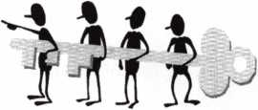

MLANJ 2001  
Annual Convention

March 29th thru April 2nd  
Somerset, New Jersey

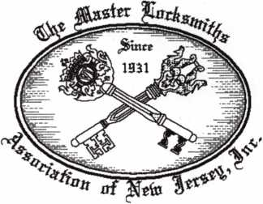

For More Information:

PO Box 2441

Morristown, NJ 07962-2441  
Phone 973-267-8884  
Fax 973-538-2248

Or visit our web site at

[www.MLANJ.org](http://www.MLANJ.org)

TO FIT.

At Stone & Berg, we pride ourselves in having more than 5,500 different **llco Unican** key blanks in stock at one time. So we’re ready when you need us most. Whether you have a call for a hard-to-find key blank or one of the popular **llco Unican** key numbers, Stone & Berg is ready to fill the order. And we are constantly updating our llco key blank invent­ory. That's how we stay ahead of the competition.

And that's how we’ll help you stay ahead of yours. So call us when you need it, and it will be there.

That’s the 30 years of Stone &

Berg tradition you’ve come to trust.



Security Hardware Distributors Association

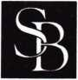

**Stone & Berg**

Wholesale Locksmith Supply Company

(800) 225-7405 • Fax: (800) 535-5625

December 2000

Keynotes

17

The original sidebar pick sets.  
Pick and decode all GM 6-cut,  
GM 10-cut, and Ford 10-cut locks.

R & D Tools



“I liked the R&D tools so  
much that I bought  
the company.”

- Steve Young -

The General Motors sidebar lock used to be one of the most pick-resistant locks in the world. That was before Doug Joosten, the founder of the R&D tool line, patented and introduced his first set of picking and decoding tools. These tools allow the locksmith to easily defeat the GM sidebar locks. Today, the R&D tools are still the fastest and easiest way to pick and decode GM-style sidebar locks.

Sidebar locks are not just hard to pick, they have traditionally been difficult to decode as well. The process usually required removing the lock and obtaining a code or disassembling the lock. The advent of airbags made disassembling the steering column a costly, time-consuming, and possibly hazardous job. Locksmiths who use the R&D pick sets to pick and decode sidebar locks without disassembling the steering column earn more money in less time than those who do the job the old fashioned way. They also avoid the liability problems associated with airbag steering column service.

The R&D pick sets make the process of picking and decoding sidebar locks relatively simple. While these precision tools are not for the “Heavy-Handed,” they provide the skilled technician with a simple and effective way to deal with GM 6-cut locks, GM 10-cut locks, and Ford 10-cut locks in a matter of minutes with no disassembly or damage to the lock.

Each pick set includes a professionally produced training video to teach you howto use the tools quickly and efficiently. The quality of the R&D pick sets is unsurpassed. For over a decade, these precision tools have been helping smart locksmiths earn more money in less time by working smarter rather than harder. Isn’t it time that you started earning more?

**Advantages of Owning R&D Tools:**

R&D pick set for 6-cut  
General Motors vehicles.

All of the tools necessary to  
pick and decode all GM 6-cut  
sidebar ignition, door, trunk,  
and compartment locks with  
no disassembly of the lock.  
Includes leather wallet-style  
case.

GM 6-Cut Pick Set with Decoder  
Order #GM -PICK-6 Sf^i price $188.00*

R&D pick set for 10-cut  
General Motors vehicles.

All of the tools necessary to pick and decode all GM 10-cut ignition locks with no disassembly of the lock. Works on all nine wafer column- mounted or dash-mounted ignition locks from ‘95 and up. Includes leather wallet-style case.

GM 10-Cut Pick Set w/ Decoder  
Order #GM -PICK-10 Sr?j price $159.00*

R&D pick set for 10-cut  
Ford vehicles.

All of the tools necessary to pick and decode all Ford 10-cut ignition locks without removing the lock. Works on all ignition locks including Escort / Tracer, Contour/Mystique, and Cougar. Includes leather wallet-style case.

Ford Side Bar Pick Set w/Decoder

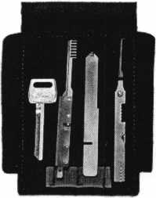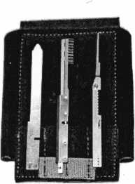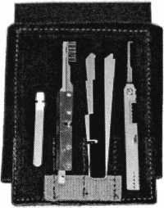

* Make GM door keys on vehicles that do not have a glove compartment without removing the door panel.
* Fit first key to GM ignition (including VATS) without air bag removal.
* Open and decode GM trunks and doors quickly - including the Fiero.
* Pick and decode Ford 10-cut ignition locks in minutes.
* Be professional - work through the lock rather than disassembling the column.

Order #F0RD-PICK Sf^j price $184.00*

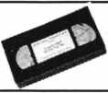

All R&D pick sets come with  
the **FREE** R&D tool set  
training video.

*Plus Shipping. U.S. shipping minimum $8.00.

P.O. Box 15532  
Pensacola, FL 32514  
fax: (850) 476-2730  
Internet: www.  
techtrainproductions. com



F^esoUf^ces */vc.

TOLL FREE ORDER LINE: (888) 801-2003

Keynotes

December 2000



M M ttai

llii MJfc ■■■■■□■■ ■■ *»

mutfllGtlt#

11 ■ ■ Ifc

■ _■ ■■■ ■ "SJmm 8818 m mSr

**liUlllauld**

By Greg Perry

Contacts come in all shapes and sizes with various gap distances and contact selections, all the choices can be confusing. If someone has an application, you can almost bet a contact or bracket has been made to fulfill it. Your goal as an installer is to chose the best contact for the job. This article will give you an overview of most of the choices available in contacts. Specific contact information and application information is best gained from the various manufacturers, their catalogs or wholesalers.

Before we explore the multitudes of contacts we must define some of the terminology and characteristics of the contacts. Switch terms NC, NO, Closed loop and Open loop can be confusing. It is very much like door handing. The terms NC or normally closed (on), and NO or normally open (off), refer to the switch state without any external force or power applied. Power can be defined as electrical, magnetic or even mechanical such as a door pushing on a plunger switch. The overhead light switch in your van is a NC switch. As long as the door is open, the switch is extended by the spring inside and the lights are on. When you shut the door mechanical force is applied to open the switch and the lights are turned off. Closed loop and open loop refer to the switch state with power applied or as you should find them installed with the building secure. Closed loop means a normally open switch and conversely an open loop means a normally closed switch. Closed loop switches are the most common style used in the burglar alarm industry. Open loops are rarely used.

The standard switch whether NO or NC will have only two terminals, one in and one out. A variation of this is to provide both types of switches in the same unit. It is commonly called a “Form C” contact. In this case the unit will have three terminals, with the following designations; NC, NO, and C or common. This will allow you to choose the appropriate switch without having to carry both styles. This switch might

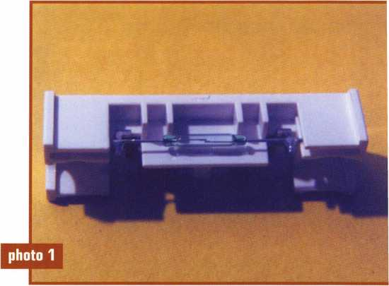

A Reed Switch without a magnet next to it.  
The contact is open.

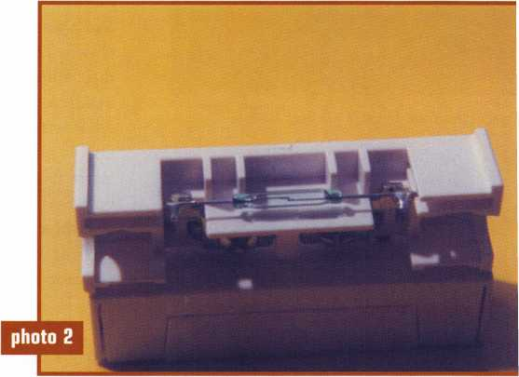

A Reed Switch with a magnet beneath it.  
The contact is closed.

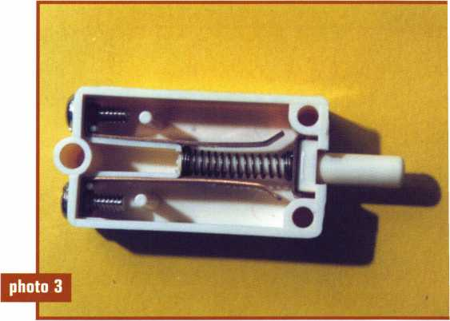

An open mechanical plunger switch.

December 2000

Keynotes

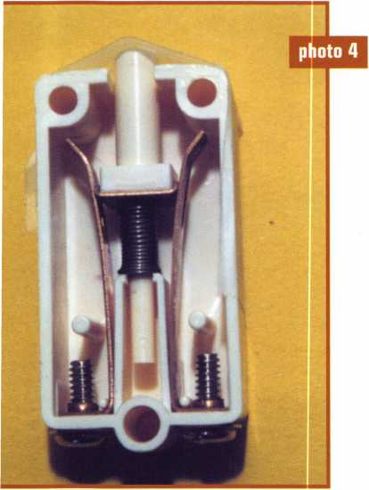

A closed mechanical plunger switch.

be thought of like a buffet line with a common entry that chooses which side of the buffet line you travel down. All contacts operate in one of these 3 basic configurations. Some may offer two or more groups of switches or a tamper protection circuit, which is simply a second closed loop switch. The tamper would trigger if a second magnet is placed near it or

if the contact is removed.

The two basic forms used to manufacture the switch mechanism are reed switch and mechanical switch. The reed switch contains two metallic reeds encased in a sealed glass vial. They are very reliable and inexpensive to manu­facture. Photos 1 and 2 are of a reed switch. The distance traveled by the reed to close the switch in photo 2 is minute. The mechanical switch is not sealed and subject to air and dirt entering the contact causing corrosion and poor performance. Photo 3 shows a mechanical tamper switch open and photo 4 is the same switch closed. The only advantage to a mechanical switch is the ability to handle a higher current flow than a reed switch. Since high current flow is not a requirement for newer alarm panels reed switches are the better choice. One method to tell the difference between the two types is to hold the contact near your ear and listen as you move a magnet next to the contact. If you hear a click the contact is a mechanical switch.

Gap distance is defined as the distance at which the contact will

reliably maintain the switch closed, or open if using a NC switch.

Most manufacturers use 1/2” or 3/4” as the standard distance. Wide gap contacts are usually good to 1”, and super wide gap contacts 1 1/2” or greater with at least one allowing a 6” gap. The wider the gap the more reliable they will be in preventing false alarms due to mis-aligned doors and frames. Why not make all contacts wide or super wide gap? They cost more than standard gap and in some cases aren’t needed or desired. High security applications might require shorter gap distances to prevent adding a magnet next to the door and opening the door while maintaining the new magnet next to the contact, bypassing the contact. Standard gap contacts are not polarity sensitive, meaning the magnet can be installed in either direction. Most wide gap and all super wide gap contacts are polarity sensitive. All contacts are sensitive to the position of the magnet in relationship to the contact. The center of the magnet is very weak; therefore the end of the magnet needs to be in line with the reed switch. In most

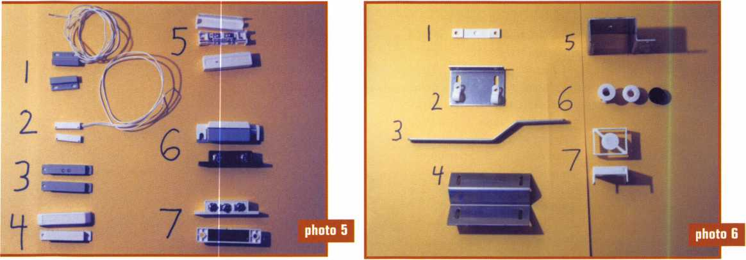

Various surface mount contacts. #6 has a different Various brackets and spaces available,

color screw cover for illustration purposes only.



Keynotes

December 2000

cases if you align the names on the housings, the orientation, both polarity and position will be correct.

Contacts come in a wide variety of housings. Surface mount, recessed and plunger or roller ball styles are the most common. Most are plastic typically available in three colors, white, brown, and gray. Photo 5 shows some of the various contacts available. Contacts 1 and 2 are only 1” long, 3/16” thick, they are considered miniature surface mounts. They may be used on the surface or concealed in the track of a window with limited space. Contacts 3 and 4 are a medium sized surface contact. Contacts 5, 6, and 7 are the most contacts they are about 2” long. Contact number 7 is a “Form C” contact which is why it has 3 terminals; C, NO, and NC. They are used in any number of different applications from surface mount to concealed inside the header of an aluminum glass doorframe with the magnet mounted in the hollow track at the top of the door. They may be installed using brackets such as numbers 2, 3, or 5 shown in photo 6. Bracket number 2 is

simply an “L” bracket, number 3 is a “Z” bracket used to move the magnet away from the surface of the door, commonly used for center hung double acting doors. Bracket number 5 is used on a sectional roll-up garage door, it wraps around the track providing a place to mount the contact.

Photo 7 includes some of the industrial contacts available. Contact 1 is special built for use on a metal door and frame without special brackets. Contact 2 comes with an armored cable for extra security. It may also be used in outdoor applications. Contact 3 is a super wide gap (up to 6”) contact typically used for loose fitting roll-up doors. Contact 4 is a buried in the concrete contact. Although they take a lot of work to install, they are the most durable contact to use where vehicles may be driving through the doorway or in other abusive applications. The magnets pictured to the right of the contacts may be used with any of the contacts.

Recessed contacts are shown in photo 8. They are available in size from the small 1/4” diameter

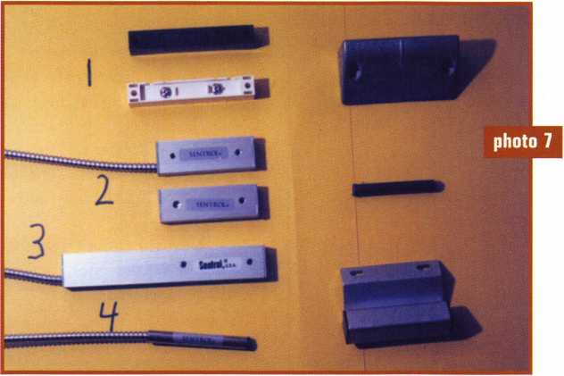

Industrial grade contacts.

The magnets to the right may be used with any of the contacts.

contact number 1, to the large 1” diameter contacts numbers 4 or 8. The 3/8” press fit contacts numbers 2, 3, 5, 6, and 7 are the most common. They are used in window and door applications. Their small

2 -*- #J

photo 8

y

Recessed contacts and magnets.

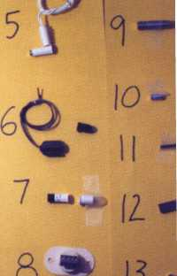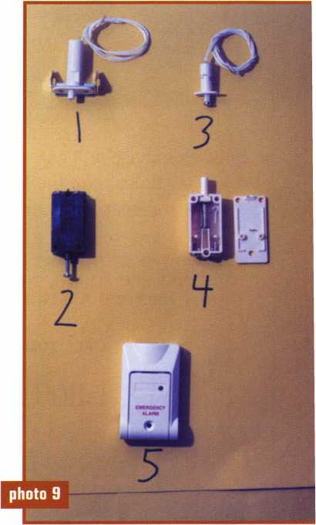

Tour plunger switches and a pull switch.

December 2000

Keynotes

size makes them very easy to conceal. Some like 2 and 7 are slightly over 3/8” diameter and rely on friction to stay in place. Others like 5 and 6 have wings or flaps to keep them in the hole. These contacts are an excellent choice for poorly drilled holes or for use in green wood, which might swell crushing the reed switch, or shrink with age allowing

the contact to fall out. Contacts 3 and 4 are for use in hollow metal doors. The extra large size insu­lates the magnet from the steel of the door. If you prefer to stock fewer sizes back in photo 6 we see some adapters labeled number 6 which use a 3/8” press fit contact for hollow metal doors. Items 9 to 13 are some of the different magnets available. Number 13 is a rare

It's True

Marray has developed the first  
screwless door loop.

Aluminum ma­terial means true anodizing.

No off color powder coat­ing or painting

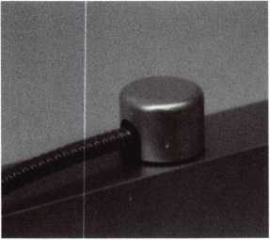

Standard 18” length. Can be ordered in cus­tom lengths

Plastic base stops shorts and pro­tects wires

Screwless base and cap means you drill two 1/2 inch diameter holes, pop the base into the hole, wire your system and snap on your covers. Simple as 1, 2, 3.

Here’s the best part We are giving away a

FREE SAMPLE TO THE FIRST 10O CALLERS WHO MEN­TION THIS ADD. A $14.40 WHOLESALE PRICE VALUE.

CALL TODAY, IT’S FREE!!

1-800-500-1449

Marray *enterprises, inc.*

At **Marray,** we’re not just modifiers, we’re Master Hardware Modifiers™  
**1128** Walsh Ave., Santa Clara, CA **95050. [www.marray.com](http://www.marray.com)**

22

***Keynotes***

December 2000

earth magnet. Rare earth magnets are very powerful especially for their size. They are an excellent choice for some of the tight fitting windows or where space is limited.

Last in my list of magnetic contacts are plunger switches and a pull switch. Plunger switches 1 to 4 in photo 9 are typically used as cover tampers. Some like 2 and 4 require drilling holes in the cabinet. Others like number 1 come with a bracket built onto it that clips over the side of the cabinet. Plunger switches or a variation of a plunger switch called a roller ball may be used for artwork by installing them in the cabinet and setting the object on top of the plunger. If the item is lifted the plunger is released causing an alarm. The last magnetic contact, number 5 is a pull switch. It qualifies as a magnetic switch because the bail or handle has a magnet built into it. The reed switch is in the base, as the handle is pulled away from the base, the switch is opened causing an alarm.

There are many more shapes or designs of magnetic contacts. All are variations of the basic switch design produced for a specific purpose. The best way for you to familiarize yourself with all the available contact designs or housing is to contact the various manufacturers for catalogs. Then start installing. Future articles are going to show some of those installation methods. Your use of contacts is limited only by your imagination.

Next time motion sensors and interior detection methods will be discussed.

Brass keys are not in any danger of immediate extinction, but more and more people are using a card instead of a key to gain access to their place of business. Access control using electronic readers and individually encoded cards offers many advantages over mechanical locking devices. Unlike metal keys which must be cut the same to work the same cylinder, each access card is unique. This means that an individual cardholder can be removed from the system without disrupting everyone else. It also means that an individual can be restricted to having access on certain days or certain times of the day. And it allows the access control system to record each card use in an “audit trail” for greater user accountability.

Several types of card reader technologies have been developed, each with its own advantages and disadvantages. For many years magnetic stripe cards were the most popular, due largely to their low cost. Using a surface-applied strip of magnetic tape (similar to an audio cassette tape) the card is swiped past a read head where the pattern of encoded information is interpreted. Wear and tear on the cards and on the read head are major problems with this technology. Wiegand cards, with an array of tiny wires embedded into the vinyl, are more durable but the lead time for additional cards can be long and the cost is relatively high. Barium ferrite cards are made with a thin sheet of metal, embedded in vinyl, and encoded with a pattern of magnetic spots. These cards are very durable and the readers, which do not have a slot or an exposed read head, are very weather and vandal-resistant. Other card readers have used hollerith (a pattern

of holes in the card), infrared (an invisible pattern which allows infrared light to pass through in selected places) bar code (a visible pattern of lines representing numbers) and i-Button (a tiny microprocessor contained in a metal disk).

As we begin the 21st century, however, proximity is the card technology of choice. Well over 50 percent of new access control installations use proximity cards. Proximity is now used more than keypads, biometrics and all other card technologies combined. Proximity readers use RFID (radio frequency identification) to distinguish which card is being presented. No physical contact between the card and the reader is required. This means that the reader could be concealed behind glass, plastic, wood or masonry (but not metal).

It also means that it is often unnecessary to fish the access card out of your purse or wallet. Wear and tear on the reader and the card is greatly reduced while user convenience is increased. In recent years, the prices for proximity cards and readers have plummeted.

If you are specifying or quoting on an access control project you will probably want to offer proximity readers. How do you decide which product to choose? Are all proximity readers created equal?

The proximity readers most often used for access control are passive and they are low frequency. Passive proximity cards do not have a battery built into them. The power they need is derived from the radio field of the reader. When the card is not close to a reader it is inactive. When the card enters the radio field of the reader, the

transponder is excited and a coded response is sent. Active proximity cards and tags with a built-in bat­tery are used for extra long-range applications. Of course, active proximity tags eventually run out of power and must be replaced.

Low frequency proximity readers transmit at 125 kilohertz (KHz). RFID readers are also being pro­duced that work at 13.56 mega­hertz (MHz), 915 MHz and 2.45 gigahertz (GHz). Each frequency has advantages and disadvantages. Several manufacturers are bringing higher frequency readers into the security marketplace.

If you decide to use a passive, low frequency reader, there are a few other considerations. These include compatibility with the access control system and compatibility with the cards.

Most modern access systems use control panels which are connected to the readers as well as to the electric locking devices, power supplies, auxiliary inputs and additional outputs associated with each door. Some of these control panels require a special proprietary input from the reader. In such cases you are forced to use readers and control panels from the same manufacturer. On the other hand, many manufacturers now use a common input format called wiegand. I mentioned above that wiegand is a type of card technology, but wiegand also refers to a format

for data transmitted from a reader to a control panel. Manufacturers whose access control panels accept card readers with a wiegand output allow you more flexibility. This “open architecture” approach even permits systems which blend card, keypad and biometric readers into a single system.

Card readers and cards must also be compatible. Some manufacturers have purchased licenses to produce readers that read another manufacturers cards. If you are adding to an existing system, or need to utilize cards which users already possess, this might be important. On the other hand, if the installation is completely new, or if you are planning to replace older cards anyway, simply order cards and readers made by the same manufacturer.

In selecting a proximity reader, another consideration is range.

How far away can the card be and still be detected by the reader? Generally speaking, longer range is better. A read range of at least five inches is usually required if the card is to be left in a purse. Extra long range, two to three feet, is especially desirable for drive-up applications and for relatively “hands-free” passageways. It is a common misconception that typical proximity readers can detect anyone in the vicinity who carries a card. Very expensive “portal” readers are required for truly hands-free applications and

MasterLink Security Products

ROGER ALEXANDER-TUTTLE  
“...understanding the needs of locksmiths...”

Mortise/Rim/Knob Cylinders • Storefront Door Hardware  
Cabinet Locks • Chain • Key Blanks • Padlocks • Pins ...and more

Local: (954) 730.9669 • Toll Free: (877) 347.9669  
Fax: (954) 486.0575

e-mail: [masterlink@mindspring.com](mailto:masterlink@mindspring.com)

3863 NW 19th Street, lauderdele lakes, FL 33311

for fool-proof “wanderer control” systems. This expense is usually not justified when access control is the objective.

The size and shape of the reader you select is also important. Most manufacturers make a standard size reader which can be installed on a single-gang electrical box or on a flat wall surface. Smaller readers are also available that may fit right on an aluminum mullion or door frame. These will usually offer a shorter read range than standard readers. Long range readers will always be considerably larger in size. For example, the RK-WL from Secura Key is 12 inches high by 12 inches wide and can read cards up to three feet away.

In considering where a proximity reader is going to be installed, keep in mind that the reader cannot be mounted behind metal. Additionally, metal should not surround the sides of the reader. Mounting most proximity readers directly on metal diminishes the performance greatly and spacers are recommended. (Secura Keys patented Dynascan® technology eliminates this problem.) If the reader is going on a door where vandalism is a problem, consider mounting behind a glass pane, or covering the reader with a piece of plywood or plexiglass. If you are planning to mount a reader where it will be exposed to rain or snow, be certain that the electronics are fully potted to keep moisture out.

There are several proximity access control systems which are full of features, yet economical. Where fewer bells and whistles are needed, consider one of the affordable stand-alone products. With the rapidly falling prices of proximity access controls, why not give your customers the card technology they really want?

***Keynotes***

December 2000

Battery

Powered

Access

Control

By Sal Dulcamarco, CML

Electronic security and access control seem to be the wave of the future, especially in commercial locksmithing where electronic locks are showing up all over the place. Most of the original electronic security devices were hard wired, and many still are. For locksmiths who might have been leery of running wires, the second wave includes a wide variety of self-contained battery powered electronic security devices. For the most part, installation of such devices is fairly similar to installation procedures of strictly mechanical door hardware.

With the continual march toward greater miniaturization of computer microprocessors, sophisticated access control has been possible with the “brains” contained within the actual confines of the particular locking device. With an external hard wired power source, the cost of installation was greater, not to mention the hesitation of many locksmiths to enter this profitable new security arena. The wide expansion of products in the category of self-contained battery powered electro-mechanical security/ access control devices is an open invitation to the previously electro-phobic locksmiths to check out the waters.

**Product Variety and Capabilities**

Except for power source and installation procedures, most of the things I say about self-contained battery powered electronic devices also apply to equivalent hard wired systems. Depending on processors, memory capacity and programming, the capabilities of the different devices may vary widely. Except for the simplest and most memory deficient devices, though, virtually all electronic devices have certain advantages in the area of “specific access” or the electronic equivalent of master keying.

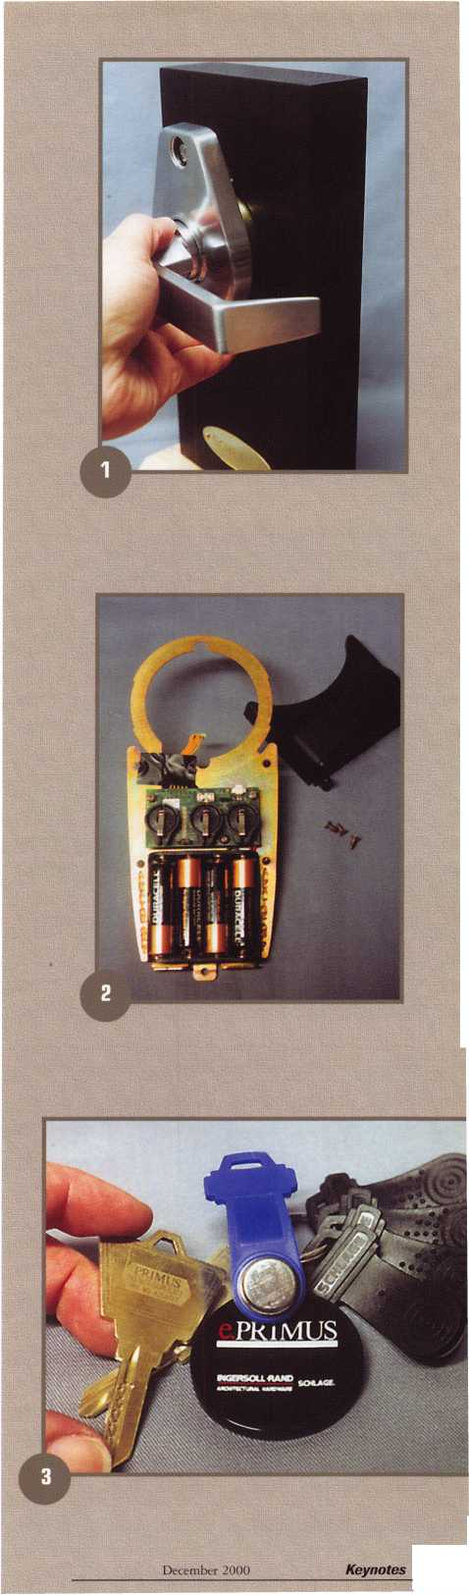

Except for glitches or flaws in the electronics (but sometimes mechanics, also) of the new generation locks, the electronic equiva­lent of master keying removes certain inherent shortcomings of mechanical master keying. In any mechanical tumbler master key system, there exist many unintended theoretical mid-level master keys. Whether you are using some type of electronic key that can be attached to a key ring or the more commonly recognizable card key, each key can have a unique assignable identity. Depending on pro­gramming and memory capacity, locks that use individually assigned keys can do things never imagined with the more traditional mechanical lock. The effect is even more dramatic when it comes to keyless (push button or key pad) access control when comparing elec­tronic systems to the older mechanical devices. Individual user codes give electronic keyless locks many distinct advantages over their (typ­ically) single code only mechanical counterparts.

**Electronic Key Locksets**

The physical appearance and actual operation of electronic keys will vary from one brand product to another. In many cases, they will be bulkier if not larger than the typical mechanical operation key. The types of door hardware will be generally comparable to that used with card keys or push button/ key pad devices. Although not every brand or type will apply, many electronic locking devices are available in both cylindrical lockset and mortise lockset forms.

Photograph 1 shows an example of Schlage’s e.PRIMUS electron­ic lockset in cylindrical lockset form. It is being installed in a lock mount through the cross bore hole. It uses iButton type touch keys. The e.PRIMUS product line includes a mortise lockset that also uses a touch key. Operation is accomplished by touching the iButton key to the key port in the outside face of the lock. Through wires that run from the outside lock assembly to the inside assembly, the key communicates with the “brains” of the lock. Photograph 2 shows an early version of the e.PRIMUS inside assembly component that con­tains the electronics and batteries. You will probably find it rather typical for most battery powered electronic locksets to use four AA type alkaline batteries.

In photograph 3, you can see a PRIMUS high security type key blank (for mechanical operation) at the left, plus an assortment of iButton style electronic keys. In the middle is the blue test key with the serial number etched into the exposed metal surface of the iBut­ton. Each electronic key has a unique identification number. The plastic handles of the electronic keys have a general resemblance to the standard Schlage bow design and contain a key ring hole to allow attachment to standard key rings. The PRIMUS mechanical key is intended specifically as an emergency key override.

One feature found on many electronic locksets is the ability to program access times for specific electronic keys and also the ability to audit lock operation. Like most other electronic locksets, mechan­ical key override operation of the lock cannot be audited. It is rec­ommended that the override key be safely secured and only used in emergency situations.

Photograph 4 shows how the iButton key is used. It is touched

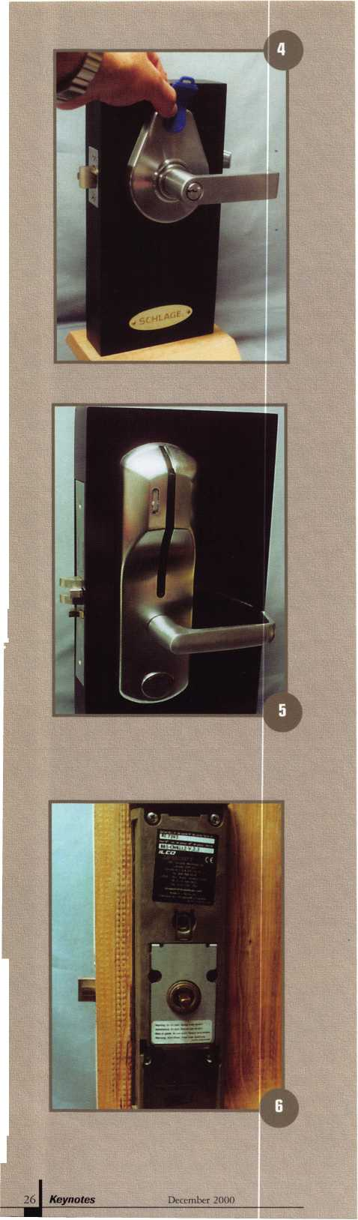

to the key port to operate the lockset. The electronic key operates differently depending on the lock function. It is available in both classroom and storeroom functions. With a storeroom function lock, touching the electronic key releases the rigid outside lever handle, and then it re-locks in about five seconds. With the classroom func­tion lock, touching the key puts the lock into passage mode. Touch­ing the key again, returns the unit to locked mode.

Card Key Devices

Card keys have taken a number of different forms, over the years. From bar codes to magnetic stripes, inserting or swiping the user’s card would transfer key ID data through the reading device to the “brains” of the lock. Various types of proximity cards allow data transfer without direct physical contact at varying distances from the reader. Like other electronic devices, processor and memory capacity often dictate the capabilities of the unit.

Photograph 5 shows a mortise lock version of the ILCO Soli­taire 850L card key lockset. Known as the LearnLok, this unit can be programmed without a computer or other electronic programming device. Although (in this form) it does not have all the capabilities of some more sophisticated card reader systems, it can be upgraded in the field. It is a self-contained battery operated device. A view of the interior assembly of a cylindrical version of the 850L can be seen in photograph 6. The space for the battery pack is toward the bot­tom. It also uses four AA type alkaline batteries.

While many electronic locksets have mechanical key overrides, the Solitaire keeps the keyed cylinder concealed (when key override option is ordered) under the “UNICAN” medallion toward the bot­tom of the exterior trim. Photograph 7 shows the medallion (or cover) removed to expose the unfilled small format IC housing. The mechanical key override is available in other versions than SFIC. The Solitaire is also available without mechanical key override, but mechanical override nonetheless.

A sample card pack is shown in photograph 8. Specific pro­gramming cards are included, as are user cards and “lockout” cards.

A simple programming process allows someone to program the lock without a computer or other external electronic device. In this mode, there is no ability for time and date stamping, and therefore no way to limit times of access for card holders. It is limited to 200 individ­ual users, but it can be upgraded to more sophisticated programming and operation.

Keyless electronic Access

While the number of competitors in the area of commercial mechanical keyless access control was very small, the electronic vari­ety of keyless locksets abounds. While more expensive hard wired key pad controlled devices have been used in commercial applications for many years, the individual electronic lockset with a self-contained key pad is a relatively new phenomenon. Like the devices operated by electronic keys or card keys, the memory capacity will ultimately limit the number of individually assigned user codes and number of auditable events (if a particular lockset has that feature).

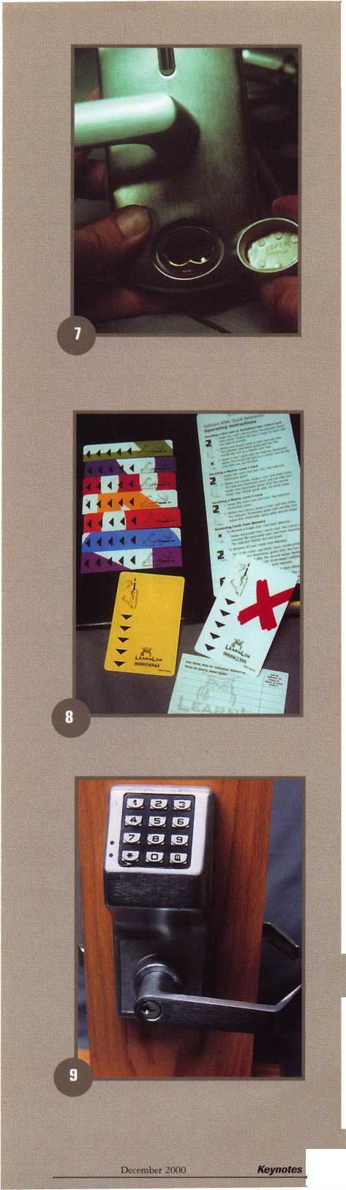

One example of a keyless electronic lockset is the Trilogy T2 from Alarm Lock, in photograph 9. This particular model lockset can only be programmed at the key pad and does not have time and day restrictions as to when user codes will operate the lock.

Although there are multiple access levels, it is limited to 15 individ­ual user codes. It does not have audit capability. With an otherwise identical outward appearance, the Trilogy T3 does have greater pro­gramming ability and it does have an audit trail.

Photograph 10 shows the unmounted T2 in pieces. This par­ticular lever handle lockset is hand changeable in the field. Chang­ing the handing on some electronic locksets will range from very dif­ficult to extremely easy. A few types are not designed to have the handing changed. Changing from right to left handed or vice versa is a relatively easy task for either the T2 or T3.

As I mentioned earlier, keyless electronic locksets can do some interesting things not typically possible for keyless mechanical hard­ware. First, there is the number of user codes. As a rule, keyless mechanical locksets are limited to one user code at a time. Some of them can be changed to new codes quickly and easily, but the limit of only one code means that all users share the same code. That means that if an employee leaves a company, everybody needs to have a new access code. An electronic lock with multiple codes (especially if every user has his or her own unique code) allows the ex-employ­ee’s code to be removed or changed without affecting anyone else. That means that the other employees don’t have to memorize a new code. Separate from termination of employment, more advanced keyless units like the T3 can limit day and time of day that any indi­vidual user’s code will operate the lock. Plus audit capability can inquire as to what code (and when) has operated the lock recently.

Photograph 11 shows a close-up of the key pad and two LED’s just to the left of it. The visual verification of red and green LED’s flashing (in conjunction with audible beeps) convey information as to correct entry of codes or just the various programming commands. Unlike keyless mechanical locksets, keyless electronic units (of vari­ous brands) often have the ability to limit or slow down the process of trying to guess the operating combinations. Depending on the particular product, automatic shut downs sometimes take place after a certain number of incorrect code entry attempts. In other cases, an audit of a particular lock may reveal a pattern of someone attempting to guess the code. The mechanical locks would never do that.

Except for the problems of dead batteries and other electronic glitches, the new generations of battery powered electronic locksets hold out the potential of greater profitability for the locksmiths who decide to tackle these products of now and the future.

All In The

By Claire L. Cohen, CML

It is not unusual to find successful businesses owned, operated and solely or partially staffed by relatives. Husband, wife, children, brothers, sisters, aunts, uncles, cousins, etc. work hand-in-hand to create and maintain successful businesses. This is very common in locksmith/ security-related companies. Each company may have a different story of how family members came into the business. Sometimes a family member would come in part-time or just to help out, and found themselves with a full-time job. Other family members may have had different areas of expertise and were asked to “lend a hand”. Although job tasks may be varied from locksmith to accountant, many relatives find it a plus to work together.

From a small mobile business to a large chain of stores, there is a “key” to the success of a family business: keeping personal business PERSONAL and business matters, strictly BUSINESS. Within the confines of the business area, personal matters should be kept out, and business matters should stay in!

Regardless of business organization, there are numerous positives as well as some negatives to having a family business. Careful planning and a commitment to open communications are paramount. Keeping business and personal issues separate, a family business can work successfully and be highly rewarding.

There are many benefits to a family team effort.

Some advantages include trust, satisfaction, closer family ties and comfort. When working with family there is sometimes a feeling of a greater level of trust and a perceived satisfaction in knowing that everyone is working toward the same goal.

Trust can be translated on many levels, from less formalized inventory control to knowing that valuable papers are secure sitting open on top of a desk. Such a level of trust is especially comforting during times when a member of the team can’t be there. With more intimate knowledge of the inner workings of the business, there may be a higher level of confidence that more than one family member with a similar level of commitment, technical competence and decision-making is able to run the organization.

Satisfaction stems from the knowledge that each person in the family is working not only to support his or her own family and to meet personal goals, but also to contribute to the economic status of all the family members of their extended family.

The family is often closer simply because the members are together more than they would be if they worked in separate companies. The closeness of the business team members may breed greater camaraderie, not only among those directly in the business but among their spouses and children as well.



Depth of caring can translate into a greater feeling of comfort for each team member. Family members some­times care more about each other than do non-related employees. Additionally, the way different members of the family were raised is often similar, so values and issues may be more easily shared whether they are busi­ness or personal.

Convenience may also come into play. As family members know more about each other and their family circumstances, more flexibility may also be achieved in hours, schedules and tasks.

There are, of course, negatives to having a family- owned business. The largest issue is the reluctance to criticize or address a person’s performance. Not only can this create hard feelings between the two related owners or team members, but also there may be a spill over into each family. Because of this, there may be a tendency to avoid concerns that would be addressed if the parties were not related. Sometimes, if issues are addressed, hard feelings can erupt. Additionally, jealousy and issues over compensation and special perks can be a common problem among related owners and their immediate families. If business team members leave the company (for any reason), there may be hard feelings lingering for a long period of time.

If problems are not addressed or resolved and are allowed to fester and if these issues are pertinent enough, the overall operation of the business could be impacted to a great degree. Or, if they are addressed and hard feelings are not reconcilable, the business may (in a worst-case scenario) fall apart as will the family.

It is important to take into consideration the impact of non-family members who may feel uncomfortable working around the hostility of family feuds. In addition to being an uncomfortable situation for family members, non-family members may feel less than comfortable.

Addressing these negatives from the beginning, families should do everything they would normally do in a job situation if they were not related-including benefit packages, regular meetings, etc. even if it is just two partners.

Fresh ideas from non-family members can also be desirable. The infusion of new ideas and objectivity are well worth considering in efforts to help the business succeed. Sometimes a non-partial non-family member can be used as the intermediary to resolve problems.

The bottom line is that a family business can be an incredibly rewarding opportunity if treated as just that, a business. Managing and operating less professionally just because the parties are related is not good business. The key to the success of a family business is to keep personal matters outside the business door and treat business matters as strictly business.

December 2000***Keynotes \*** 29

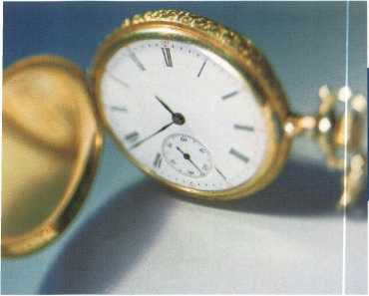

**Time Is Moving On**

By Don Dennis

If there is one thing that I have always grappled with, it is time. There is never enough time. We battle, as locksmiths, to get to the next job faster. This means buying new tools to do each job faster and learning enough about people skills to deal with our customers in efficient yet polite ways. It all amounts to saving time for that quality time with our favorite passions and still making enough money to make ends meet. It is that balancing act that we refer to as life.

It was not until my last article that I discovered a value at looking at the past. I mean a value beyond the concept of learning from our mistakes. In working on the Chevy Bel Air article, I found a wonderful thrill of playing once again with something that I had not done in so very many years. It’s the same as looking at a photo album of the past times and smiling at how wonderful that particular time was.

Short of playing a violin, I have found a value in taking another look at the past and how we have gotten to this point in time. I can remember that time when my code books consisted of only three books. All three of them were Reed Code Books. It was a time before the influx of automobiles made outside of the USA.

When I compare that time to the current situation, I was so very simple and naive. I’m not putting anything or anybody down here, only discovering how much can change within a profession and how much

Model A Curtis Clipper with automotive code hook  
for 1954-55 and a GM decoder.

,i Keynotes December 2000

more it will change in the future. Business is a constant war of fighting for dollars. All of this is nothing more than it has ever been. It is the nature of the beast.

From this perspective the past and the future come together making a photo or a great musical composition for the making of a great movie. Let me show you what I’m talking about with just a short piece or score of the overall composition.

When I look into the vehicles and shops of the modern-day locksmith, I see all sorts of punch machines used in the making of original keys. The concept of the punch key machine originates from the need of a key cutting device that would do the job without electricity. W.H. Curtis filed for a patent on July 2, 1934, which subsequently was granted by the patent office in March of 1935. This was for the Model A of the Curtis clipper called The Handee Key Punch. The improvement process, as far as I have been able to find out, continued with the clipper through the Model E. After the Model E, the clipper developed into the Curtis #14 and then on to the current models as we know them today. The Curtis clipper #15 arrived on the market in 1969.

In 1932, a business, who’s name I have yet to discover, was formed by William Abrams and his son, Howard. There was an initial investment of $20,000 and Howard’s job was in the selling of small hand- operated key cutting machines. It is my belief that it

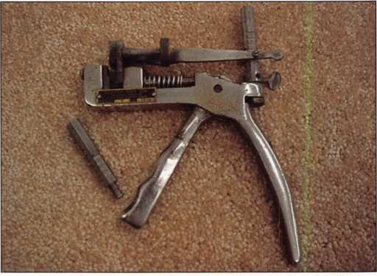

Model E Curtis Clipper with removable post for different applica­tions. The original clipper did not have an easily removable post.

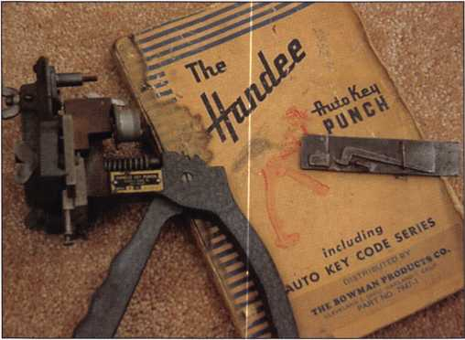

was the selling of The Handee Key Punch machine to the automotive service industry. The first full year of business, 1933, yielded the company $5,000. For the time, this kind of money was considerable. Howard’s name was used on a patent that was issued on December 22,1949 to Curtis Industries. I do not know what happened to W. H. Curtis in this process.

I know that in the writing of an article it is best not to say that there might be something that you don’t know or are uncertain of. In this particular case, I am not ashamed to say it. There has been very little written about Curtis and its early beginnings. The current company is nothing like its early beginnings. It is now part of different holding companies and is very diversified. An example is where it currently exists. Up until a couple of months ago, Curtis Industries, Inc. was part of Paragon Corporate Holdings, Inc. of Delaware with NES Group, Inc. as the sole stockholder of the company shares. Paragon operated in two industries, one was printing equipment and supplies while the second was automotive and industrial supplies. The automotive was Curtis Industries and the industrial supply was through the A. B. Dick Company. As I understand it now, Paragon has been purchased by other concerns.

While Curtis Industries was formed in May of 1946, it has entertained many names over the years. I remember them best as Curtis Noll Corporation. As it turns out, the Abrams family released control of the company in 1964 with a buy out by Ohio Forge and Machine Corporation. This would become Curtis Noll Corporation, with six other subsidiaries. There are a lot of highlights for Curtis as it expanded across the United States in its warehousing and acquisitions. This continued as its interests went into other countries all over the world. All of this has come out of a hand held clipper that made me money that began so many years ago. Maybe someday I’ll finally put this Curtis history all together but for now it is simply a walk down memory lane. A memory lane that has a small window that is viewing the future.

Is it time for our locksmithing industry to truly fragment into an industry of specialization? Will the single individual locksmith remain in business or will only those with good business abilities remain in business with their larger shops and many employees? Will the locksmith remain a specialized part of the community or will some other interest like the alarm

Model #14 Clipper with removable disks and carriages.

industry consume the locksmith? Assa Abloy now owns Corbin-Russwin as well as Yale and Chubb Safe. Ingersoll-Rand has Schlage and has just acquired the electronics of Interflex Datensysteme GmbH of Germany. Could it be that the future would allow large conglomerates to eventually entertain the thoughts of entering the locksmith’s service sector?

Is this the reason why we are a part of ALOA? Oh my, so many questions and so little time.

INTERCHANGEABLE CORE PRODUCTS

Interchangeable

with:

•BEST

* ARROW
* FALCON

P

KILLEEN SECURITY  
PRODUCTS

|  |  |
| --- | --- |
| That's what KSP is all about!  Ask your wholesaler about our drop shipping. | 33 Hermon St. Worcester, MA 01610 Phone (508) 798 3200 |
|  | • iMX |Z900J m * CP- |

December 2000

Keynotes

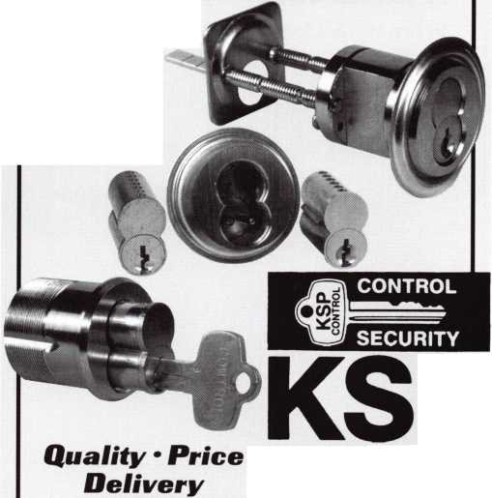

This year, the ALOA Scholarship Foundation awarded 25 full package scholarships to ALOA 2000 in Las Vegas, Nevada. Of the 25 awarded 21 recipients accepted and took advantage immediately by attending the classes offered in Las Vegas. Ask any one of those recipients and they’ll tell you how the scholarship was beneficial in gaining knowledge for the improvement and development in the field.

The Scholarship Foundation worked hard at ALOA 2000 and will continue to work throughout the year to raise funds for future awards.

Don’t get left out next year. ALOA 2001 in Baltimore will provide more educational and career opportunities for locksmiths and others in the security industry. Take the time and complete the scholarship application at the right.

You can take advantage of one of our associations most valued resources and learn more about the trade. Who knows, you could be one of the next recipients. The ALOA Scholarship Foundation is waiting to hear from you.

TEXAS LOCKSMITH ASSOCIATION

***Annual Convention & Trade Show***

February 6-11, 2001  
Omni Austin Hotel Southpark  
Austin, Texas

For Information:

Judy Clifford @ (979) 297-2413 Email: [clifford@tgn.net](mailto:clifford@tgn.net) Jim Hetchler @830-606-1727 See Website @ <http://tla.tsx.org> Tollfree: 1-877-TLA-INFO

Featuring:

ALOA Ace classes Free Clinics & Seminars Exhibits

Annual Party & Awards Ceremony PRP Testing by ALOA

A CAPITAL INVESTMENT IN YOUR FUTURE!

—si

Keynotes

December 2000

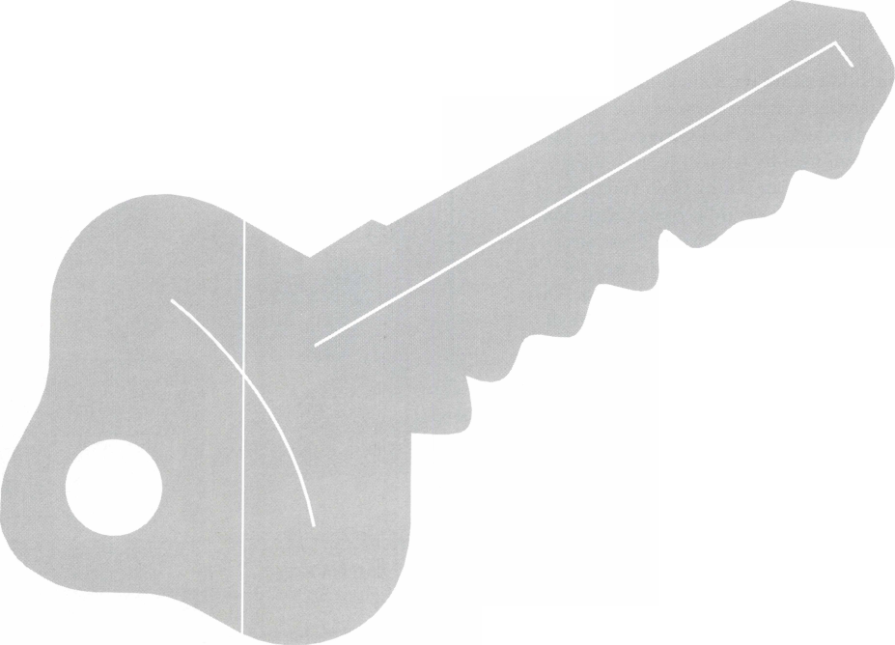

Scholarships are awarded to those individuals who demonstrate their financial need and their desire for more education in the locksmithing field. If you or someone you know fits the above criteria, please fill out the application on this page and send or fax to the ALOA Office at 3003 Live Oak St., Dallas, Texas 75204 by the due date on February 1, 2000. The fax number is (214) 827-1810. Don’t forget to include your letter stating your reason for applying, your three letters of reference. No late or incomplete applications will be considered.

ALOA SCHOLARSHIP FOUNDATION, INC.

ALOA/SAVTA SCHOLARSHIP APPLICATION  
3003 Live Oak Street; Dallas TX 75204; (214) 827-1701

Please print or type

NAME

PRPLEVEL

HOME ADDRESS. HOME PHONE

CITY.

ALOA/SAVTA #.

STATE ZIP

DOB

/ _/

PRESENT EMPLOYER.

WORK ADDRESS

POSITION

EDUCATIONAL LEVEL {YEARS) DEGREE, IF ANY_

_ WORK PHONE- FAX

CITY.

STATE.

ZIP

□ FULL TIME □ PART TIME TAKE HOME PAY $_

LENGTH OF TIME IN LOCKSMITHING .

OWNER/SUPERVISOR’S FULL NAME

MEMBERSHIP IN TRADE ASSOCIATIONS (LIST BY NAME). MARITAL STATUS SPOUSE’S OCCUPATION _ COMBINED HOUSEHOLD ADJUSTED GROSS INCOME $_ CLASSES DESIRED

SPOUSE’S TAKE HOME PAY $_

NUMBER OF DEPENDENTS.

DATE OF CLASSES

ORGANIZATION SPONSORING CLASSES: □ ALOA □ SAVTA □ OTHER (PLEASE NAME).

LOCATION.

ALOA Scholarships are granted to selected individuals desirous of entering the locksmithing field or to selected individuals already in the locksmithing field who wish to improve their professional skills through education.

Applications for classes being taken locally must be received a minimum of 60 days prior to the date of the class, and will be reviewed as they are submitted. Scholarships for classes at the ALOA or SAVTA convention will be awarded each year at the ALOA Scholarship Foundation meeting preceding the convention and must be received by February 1 each year.

Please attach to this form a letter stating your reason for applying for a scholarship, what you plan to do with the knowledge you obtain and any other information you feel may be helpful to the scholarship board in making its decision. In addition, attach three let­ters of reference from individuals who have personal knowledge of your background and character. The letters should contain their names, addresses and phone numbers. It would be helpful if at least one of these references is an ALOA or SAVTA member.

All scholarship recipients will be required to provide a 3x5 inch photograph of themselves.

APPLICATION CHECK LIST

Only complete applications will be considered for scholarships. An application is considered incomplete unless ALL of the above requested information is received before the deadline: 60 days prior to the date of a class or February 1 for ALOA/SAVTA convention classes. Please send this application after checking off each of the below.

* I have filled in each blank on this form.
* I have written and enclosed a letter explaining my reason for applying.
* I have enclosed three letters of reference.
* I am submitting this in time to be received 60 days prior to the date of a class or by February 1 for ALOA/SAVTA convention classes.

CERTIFICATION OF APPLICANT:

I certify that the information contained herein, and all supplemental forms are complete and correct to the best of my knowledge. I further certify that if I am selected as a scholarship recipient I will use the knowledge gained for the improvement, development and advancement of the locksmithing profession.

Signature.

Date

/

/

December 2000

Keynotes



To Help ALOA’s Legislative Efforts!

In January 2001, we will have a new and effective tool for bringing locksmiths and their state legislators closer together - right through the ALOA web site. Our new service will connect locksmiths to every member in their state legislature. It will provide up-to-date information about key issues, give users quick and easy access to state and local officials, and will enable them to contact legislators by customized or personalized e-mails, faxes or standard letters. It will be able to conduct a 5 and 9-digit ZIP Code search so that you can identify your state and local officials quickly. It will provide you with biographical data and contact information for your particular legislator. It will create personalized correspondence that can be sent via e-mail or printed out as a letter for faxing or mailing purposes.

This feature will transform our web site into an on-line political powerhouse by instantly adding thousands of pages of information about state and local officials and other up-to-date information.

It will enable us to control the legislative agenda at the state level and create an instant on-line forum that will not only inform and educate, but engage members in the political process at the state level. Grassroots lobbying at its finest!

However, as we continue to expand our resources and become more competitive in the legislative arena, we need the monetary resources to match our successes. In your recent dues billing, you will notice a donation of at least $14.95 to the Legislative Fund. Please add your donation onto your annual dues. This is the minimum that we are asking, and encourage you to give more if you can. Those that contribute will be given a Legislative Action Network Member kit to use in their grass roots efforts. Members who donate $100 or more become Legislative Action Network Council members, and enjoy the following extra benefits: direct input into the legislative strategic plan that guides all legislative activities; discounts on ALOA bookstore items; 10 percent rebate on all ACE classes; and complimentary legislative convention merchandise.

The 2001 legislative session is already beginning to look busy. Visit the web site now at <http://www.aloa.org/news/legislation.cfm> to find out what’s the latest in your state!

34

Keynotes

December 2000

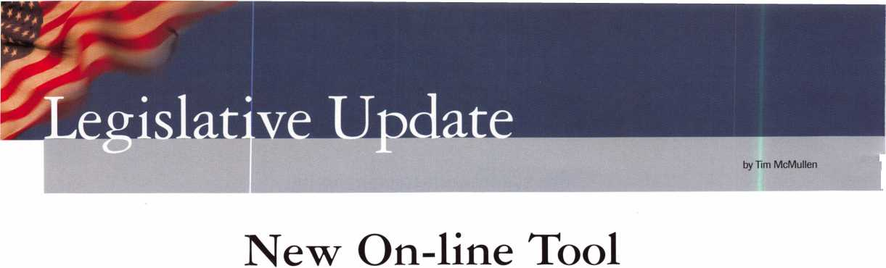

**Keynotes**

Classified

Dept

**Classified Advertising Policy**

**Classified advertising space is provided free of charge to ALOA members, and for a fee of $.60 per word, $15 minimum for non-members. Classified ads may be used to advertise used merchandise and overstocked items for sale, “wanted to buy” items, business opportunities, employment opportunities/positions wanted and the like. Members or non-members wishing to advertise services or new merchandise for sale may purchase a “Commercial Classified Ad,” for a fee of $1.30 per word, with a minimum of $40. Each ad will run for two issues. For blind boxes there is a $5 charge to members and non-members. All ads must be submitted in writing to the ALOA office by the fifteenth of the month, two months prior to issue data Send to Keynotes Classifieds, 3003 Live Oak St., Dallas TX 75204-6186. ALOA reserves the right to refuse any classified advertisement that it deems inappropriate according to the stated purpose of the classified advertising section.**

■ EMPLOYMENT

Automotive Locksmith Wanted

12/F/3: Relocate to South Florida and throw away your deadbolts and three keys for a dollar. We run over 300 calls per week. You must own a truck with tools and code equipment to cut all foreign and domestic keys. You can earn $800 to $1300 per week. Please if no truck or tools, no calls!

South Florida hock and Safe (800) 928-2926

Security Technicians Needed

12/F/3: Looking for experienced, motivated, hardworking technicians and team players. Great income potential. We offer paid holidays, vacation, medical and 40IK plan.

Don’t delay, fax resume today.

Liberty hock and Safe 5470 W Sahara Ave has Vegas, NV 89146 (702) 876-5470 www. li hertylock. com

Locksmith Wanted

12/F/3: The County of San Luis Obispo, Calif, is looking to hire a locksmith. The salary ranges from $2667-13243 per month. For information contact:

Andy Zigan, Building Maintenance Supervisor (8050 781-5121 [azigan@co.slo.ca.us](mailto:azigan@co.slo.ca.us)

Service Technician Wanted

12/F/3: Locksmith service technician needed at fast paced growing firm. Looking for great pay, positive work environment and full benefits package? Fax resume to:

Mr. Schmidt

Loss Prevention Systems Inc.

22865 Savi Ranch Pkwy #B Yorba Linda, CA 92887 (714) 279-0092 fax

Service Technicians Wanted

12/F/3: Safemasters has several opportunities available for experienced technicians knowledgeable in any of the following specialties: Access Control, CCTV, Safes, or General locksmithing. Our employees enjoy flexible scheduling, 401K and company match, health, dental and vision insurance, long and short term disability, company vehicles, opportu­nities for advancement, company paid training programs, technical skills updates, new product training, trade schools and college courses, generous leave programs, etc. We have locations in Maryland, Virginia, Wilmington (DE), Philadelphia, Pittsburgh,

Boston, New Jersey, Indianapolis and Chicago. Stop by one of our offices and talk to a manager about your needs and how we can fulfill them. Safemasters Headquarters Human Resources 2700 Garfield Ave, Suite 200 Silver Spring, MD 20910 [hr@safemasters.com](mailto:hr@safemasters.com)

Locksmith Wanted

ll/F/3: Busy shop in Woburn, MA has immediate opening for a self- motivated, reliable Locksmith. Large customer databases for Automotive, AAA, Commercial and Residential accounts. Applicant must have own van and tools. Guaranteed 50% commission. A great opportunity for the right individual. All inquiries are kept strictly confidential. Send resume: John

hocks & Keys, Inc.

PO Box 222 Woburn, MA 01801 [Jobs@locks-keys.com](mailto:Jobs@locks-keys.com) (781) 933-9999

Locksmith Wanted

ll/F/3: Locksmith wanted in Chicago and Suburbs. Full or part time. Experi­ence preferred. Good benefits, excellent salary, terrific co-workers. Call Eric

Pro-Tek Lock & Safe Co.

(630) 655-3090

Dispatcher/Operations Manager Needed

ll/F/3: Energetic, organized, service oriented individual with experience in locksmith field. Join an established, growing company in Southern California. High salary plus benefits. Send inquiries to:

Keynotes’ Classifieds 3003 hive Oak St Dallas, TX 75204 (214) 827-1810 fax

Locksmith Wanted in Hawaii

ll/F/3: Opening in top company for locksmith with solid work history, professional skills and mature attitude. Forward inquiries to:

(808) 572-0591 Voicemail jfmf@gte. net

Manager of Operations Wanted

1 l/F/3: After 48 years and three generations of ownership, we are seeking qualified candidates to manage the overall operations of our successful locksmith corporation. We specialize in high-end, commercial and multi-unit accounts. We are the most recognized name in LAs San Fernando Valley. This gem of an opportunity is open to candidates with proven leadership and organizational skills necessary to manage a fast-paced environment. The right candidate will earn a top salary and will be responsi­ble for all aspects of the business. High energy and a “roll up your sleeves” mentality fits the bill. For more information contact or send resume to: Jack Flam (818) 789-5024 (818) 990-2281 fax

Make $ $ $

9/F/3: Relocate!! Company in Houston, Texas is seeking a serious experienced locksmith with tools and vehicle. Great pay, bonuses, benefits and paid vacation.

Contact Fred:

(281) 497-5555 (281) 830-9441 (713) 266-4350 fax

December 2000

Keynotes



Keynotes

Classified

Commercial Locksmith Wanted

9/F/3: Established in 1900 Atlanta’s oldest locksmith business needs experienced Locksmiths and electronic security technicians to support rapid growth. Great pay, paid insurance, retirement plan, paid vacation and hol­idays. Need to be a highly motivated team player, bondable and have a clean driving record. Please fax resume to: Calvin Pinson

Downs Safe & Lock Co., Inc.

1846 Cheshire Bridge Road Atlanta, GA 30324 (404) 873-2515 (404) 873-4581 fax

Experienced Security Professional Wanted

9/F/3: Maryland security service company seeking an experienced security professional to join our team. Our service areas include high security locks, safes, access control, CCTV and general locksmithing. We service government and commercial clients throughout Maryland and the metro­politan District of Columbia area.

We offer a competitive salary, excellent health, dental, life, short and long­term disability insurance. We also offer paid holidays, vacation, retirement plan with company contribution, bonus programs, company vehicle, uniforms and a great work environ­ment. A signing bonus is available. Successful applicant will be subject to a security investigation and must meet eligibility requirements for access to classified information and have an acceptable driving record.

Dave Harris, CML Chesapeake Security Service Co. (301)855-9131 (410) 535-1372 fax clssc@ Chesapeake, net

Experienced Service &

Shop Technicians Needed

9/F/3: Due to continued growth, we are looking for outside and inside



**r Classified Advertising Policy**

**'Classified advertising space is provided free of charge to ALOA members, and for a  
fee of $.60 per word, $15 minimum for non-members. Classified ads may be used  
to advertise used merchandise and overstocked items for sale, “wanted to buy”  
items, business opportunities, employment opportunities/positions wanted and the  
like. Members or non-members wishing to advertise services or new merchandise  
for sale may purchase a “Commercial Classified Ad,” for a fee of $1.30 per word,  
with a minimum of $40. Each ad will run for two issues. For blind boxes there is a  
$5 charge to members and non-members. All ads must be submitted in writing to  
the ALOA office by the fifteenth of the month, two months prior to issue date. Send  
to Keynotes Classifieds, 3003 Live Oak St., Dallas TX 75204-6186. ALOA reserves  
the right to refuse any classified advertisement that it deems inappropriate  
according to the stated purpose of the classified advertising section.**

service technicians. Our company has been in business since 1880 and is located in the beautiful Pacific Northwest. Argens Inc. is a multi­dimensional company. We target commercial and industrial accounts of all sizes. Our company specializes in general locksmithing, electronic s ecurity (card access & CCTV), door servicing and gate systems. We are an employee driven company with excellent pay, benefits, sales incentives and can offer advancement as our growth continues. Send resume to:

Jim Ring Argens Inc.

84 S Main Street Seattle, WA 98104 (206) 623-2662 (206) 622-5056 fax [argens@w-link.net](mailto:argens@w-link.net)

Experienced Locksmith Required

9/F/3: Experienced locksmith required immediately for national locksmith company. Minimum 2 1/2 years experience. Electronic and safe background, (Defiant) asset for candidate. Excellent salary package and full benefits. Apply to:

John Hanning Chubb Lock & Safe #8 5708 1st Street SE Calgary Alberta Canada (403) 255-2222 (403) 258-1702 fax

Electronic Locksmith Wanted

9/F/3: Locksmith experienced in installing and servicing access control systems needed. Need expertise in installing electric strikes, maglocks, keypads and card readers. Send resume to:

Electronic Locksmith PO Box 1056 Birmingham, AL 35201

Locksmith Position Available

9/F/3: Full and part time positions available with busy locksmith shop in Ventura County California. Desired 2-3 years experience with automotive, commercial, residential service calls. Need flexible inside/outside person. Commissions paid in excess for after hours service calls. Newer air Iconditioned trucks provided. Would prefer applicant with own tools. Please inquire a.s.a.p.

[ExitatMainSt@aol.com](mailto:ExitatMainSt@aol.com)

(805) 701-3444 (805) 794-4458

Experienced Locksmiths Wanted

9/F/3: Wanted!! Austin, Texas and San Francisco, Calif., experienced locksmiths in auto, commercial and residential. America’s fastest growing Mobile Locksmith. Best salary and benefits.

David

(512) 657-6404

M WANTED TO BUY/SELL

Key Machine For Sale

12/F/2: For sale, Taurus B Key Machine. Never used in truck, in very good shape. New $1,450, asking $725. Call:

Gene Winne (201) 327-4200

Few Items Wanted

12/F/2: We are a small, but growing business and are looking for a few items to help us grow. Looking for used Transponder Key Reader, Transponder Key Detector and a Transponder New Generation Star Tester.

James Mary on

Maryon’s Locksmith Co., Inc.

Upper Marlboro, MD (301) 627-5876

Keynotes

December 2000

Wanted to Buy

ll/F/3: Wanted. Old auto key blanks, Hurd, Briggs-Stratton and Yale. Will pay $1.

Douglas Vogel 4779 Meadow hark Ln Dexter, MI 48130

M BUSINESSES FOR SALE

Locksmith Business For Sale

12/F/2: Established locksmith business for sale in Fairfax, VA. Same location since 1978. The store is located just outside of the nation’s capital on two major roads. Three equipped vans. Automotive, residen­tial, banks and over 300 commercial accounts. Also handle safe opening, repairing and moving. Fully equipped store capable of cutting vats, pats, transponder and sidewinder keys.

New long term lease on store with additional warehouse/shop in rear. Owners ready to retire. Asking $270K. Tony or Ralph (703) 273-2177

Business For Sale

ll/F/2: Tired of the rat race? Here’s the ideal situation for someone who wants to raise a family in the upper Mid-West or seeks a more civilized environment and still make a comfortable living. Established in 1980, we specialize in Commercial & Institutional accounts with CCTV, High Security Locks and Access Control Systems. In the heart of Wisconsin with excellent hospital and one of the nations largest privately owned medical clinics. Downtown walk-in shop location-little competition. Send all inquiries to: Keynotes’ Classifieds 3003 Live Oak St Dallas, TX 73204 (214) 827-1810 fax

Business For Sale

ll/F/2: Tampa, Florida’s foremost mobile locksmith service. Established in 1982. Sale includes merchandise, assets, 1996 service van, customer list and telephone number. Call:

Richard (813) 983-2028

Business For Sale

ll/F/2: Successful safe and lock business for sale. Great location, two years left on lease and only shop in town! Large showroom, Medeco key ways, exclusive territory for safe dealership, excellent reputation in large area, lots of referrals. Owner moving, but will stay for transition and training if necessary. Bring your equipment and take over accounts, or get what you want from my arsenal. Employees will stay with new owners, if desired.

Ask for Jim.

(336) 783-2743 (336) 399-3330

Locksmith Business For Sale

9/F/2: Locksmith business for sale in northwest Alabama. Established in 1973. Tri-state service area of 250,000 plus population. Industrial, commercial and banking accounts. Mobile service, large walk-in traffic. Gross $125,000. Good growth potential. Terms nego­tiable. Mild Alabama winters. TVA Lakes on Tennessee River for boating and fishing. Lake shore homes.

Security Lock & Key PO Box 2191 Florence, AL 33630 (236) 764-3349 (236) 766-7083 fax

Mobile Locksmith Business For Sale

9/F/2: Established in 1976, family run and operated and serving the Marion/Polk County area in the beautiful Willamette Valley. Currently

being run as a one man business with lots of potential to be a shop/mobile business as it has in the past. Owner is anxious to sell, due to change of careers and relocation. Includes a 1993 Dodge Ram 350 van with custom interior, Redi-line converter, Pentium laptop computer, HPC locksmith software, an outstanding selection of power, hand and locksmith specific tools, inventory, key blanks, etc. Also includes company name, customer list, customer records, 800 number, custom phone number, web site, great reputation, etc. Currently grossing $30,000 part time, but a smart aggres­sive businessman could easily double that in no time. Asking $35,000 or best offer. Owner will partially finance.

PO Box 3698 Salem, OR 97304-0698 (303) 364-3397 action lock @home. com

Locksmith Business For Sale

9/F/2: Well established lock and safe business for sale in the mid-west.

Includes all inventory and equipment, two fully equipped mobile service trucks, and shop located on corner of very busy intersection. Gross sales for 1998-$190,000; 19994240,000.

Asking for $230,000 including property, which appraised at $95,000. Current owner can assist with financing. Inquiries may be made by calling:

(813) 634-0882

Business For Sale

9/F/2: Well established lock shop in Northern California tourist town in the Redwoods. Close to rivers, lagoons, mountains, fishing and hunting. Twenty years at the present location and still growing. Commercial and residential accounts, safe sales and opening, road­side contracts and two fully stocked vans. Owner wants to semi-retire, but will stay on for smooth transition.

Grossing $170,000. Asking $130,000 plus $21,000 for a new fully stocked van plus inventory. Send inquiries to:

PO Box 961 Willits, CA 93490

December 2000Keynotes I 37

Associate

Members

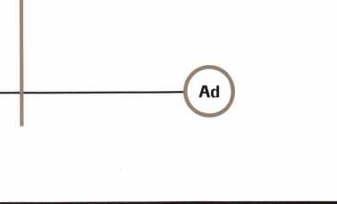

Buddy Products

1350 S. Leavitt Street

**MANUFACTURERS**

A & B Safe Corp.

171 S. Delsea Dr.

Glassboro, NJ 08028  
(800) 253-1267; FAX (856) 863-1208

0 (0 0 0

Abus Lock Company

3555 Holly Lane North  
Plymouth, MN 55447-0507  
(800) 352-2287; FAX (612) 509-9939

©

Adams Rite Manufacturing Co.

P.O. Box 1301  
LaPuente, CA 91749-1301  
(562) 699-0511; FAX (562) 699-5094



Adesco Safe Manufacturing Co.

web: [www.adesco.com](http://www.adesco.com)  
email: [sales@adesco.com](mailto:sales@adesco.com)  
(800) 821 -6803; FAX (562) 408-6427

0

Alarm Lock Systems, Inc.

345 Bayview Ave.

Amityville, NY 11701  
(800) ALA-LOCK; (516) 789-3383

©

Aiphone Intercom Systems

1700-130th Avenue, NE  
Bellevue, WA 98005  
(425) 455-0510; FAX (425) 455-0071

0 0 0

American Lock Co.

3400 West Exchange Road  
Crete, IL 60417-2099  
(708) 534-2000; FAX (708) 534-0531

§ ©

American Security Products (AMSEC)

11925 Pacific Ave.

Fontana, CA 92337-6963  
(800) 423-1881; FAX (909)685-9685

0 0

Baldwin Hardware Corp.

1841 E. Wyomissing Blvd., Box 15048  
Reading, PA 19612  
(610) 736-4012; FAX (610) 796-4493

0 (0)

Chicago, IL 60608

(800) 886-8688; FAX (312) 733-8536

0

BWD Automotive

900 Ravenwood Dr.

Selma, AL 36701

(334) 874-9001; FAX (334) 874-6011

0 (0

Chicago Lock Company

10100 88th Ave.

Pleasant Prairie, Wl 53158-0069  
(800) 445-3204; FAX (414) 947-7178

©

Corbin Russwin Architectural Hardware

P.O. Box 25288  
Charlotte, NC 28229  
(800) 543-3658; FAX (800) 447-6714

10) (0 (0 (0

Curtis Industries

6140 Parkland Blvd, Ste. 300  
Mayfield Heights, OH 44124-4103  
(800) 555-5397

0) (0

DETEX

302 Detex Dr.

New Braunfels, TX 78130  
(800) 729-3839; FAX (830) 620-6711

0 (0) (0 0 0)

DSC Group of Companies

3301 Langstaff Road  
Concord, Ontario, Canada  
(905) 760-3000 ext. 2200; FAX (905) 760-3040

0 0 (0 0 (0

Don-Jo Manufacturing, Inc.

P.O. Box 929  
Sterling, MA 01564  
(508)422-3377; FAX (508) 422-3467

0) (0

Door Controls International

2362 Bishop Circle East  
Dexter, Ml 48130

(800)742-3634; FAX (800) 742-0410

0 0 (0 0

ESP Lock Products, Inc.

375 Harvard Street  
Leominster, MA 01453  
(978) 537-6121; FAX (978) 534-9109

0 <0

Associate members of the Associated Locksmiths of America (ALOA) manufacture or distribute materials or equipment, or provide services, for the security industry. Many have donated money, services and equipment to ALOA in addition to their annual dues. Their support of ALOA projects enhances overall membership benefits and we encourage our members to patronize these firms. If you know of a potential candidate for associate membership, please contact the ALOA Membership staff at (800) 532-ALOA. Associate member dues are $300 per year and entitle the payor to use the ALOA logo, and receive selected discounts on ALOA products and services.

Legend

© Alarms: Personal, vehicle, electronic, fire, burglar, and exit ® Bank security equipment ® Automotive: Lockout equipment, key chains/rings

*§ Builders Hardware: Door closers, furniture/decorative hardware, viewers, emergency exit devices ® Business/Technical & Educational: Books, reference guides, publications, computer software

® CCTV/Photo Imaging: Cameras, monitors, photo ID equipment, cables © Electric/Electronic Security: Card access control and readers, surveil­lance, electric/magnetic locks and strikes, keypads

® Lock Devices: Auto locks, cylinders, emergency exit/entrance control, locks (various types), strikes ® Tools & Supplies: Key blanks, cutters, picks, rings/hooks, custom van/truck supplies

© Safes/Vaults © Other

Folger Adam Security, Inc.

16300 W. 103rd Street  
Lemont, IL 60439

(630) 739-3900, FAX (630) 739-6138

© ©

Fort Lock Corp.

3000 N. River Rd.

River Grove, IL 60171  
(708) 456-1100, FAX (708) 456-9476

0 0(0000

Grobet File Co. of America

750 Washington Ave.  
Carlstadt, NJ 07072  
(800) 962-7242; FAX (800) 243-2432

®

H.E.S., Inc.

2040 W. Quail Ave.

Phoenix, AZ 85027  
(602) 582-4626; FAX (602) 582-4641

0 0(0

|  |  |
| --- | --- |
| | Keynotes | December 2000 |
| t |  |

|  |  |  |
| --- | --- | --- |
| HPC, Inc.  3999 N. 25th Avenue  Schiller Park, IL 60176 (847) 671 -6280; FAX (847) 671 -6343 | La Gard, Inc.  3330 Kashiwa Street  Torrance, CA 90505 (310) 325-5670; FAX (310) 325-5615 | STRATTEC Security Corp.  3333 W. Good Hope Rd.  Milwaukee, Wl 53209 (414) 247-3333; FAX (414) 247-3329 |
| 9 9 9 | 9 9 9 | 9 9 9 |
| HID Corporation  9292 Jeronimo Road  Irvine, CA 92618  (949) 568-1600; FAX (949) 568-1680 | Lucky Line Products  7890 Dunbrook Rd.  San Diego, CA 92126 (619) 549-6699; FAX (619) 549-0949 | Sargent & Greenleaf, Inc.  P.O. Box 930  Nicholasville, KY 40340-0930 (606) 885-9411; FAX (606) 887-2057 |
| • # | • | • © 9 9 |
| High Tech Tools  1400S.W. 1 Street  Miami, FL 33135  (305) 649-7014; FAX (305) 541 -0074 | M.A.G. Engineering & Mfg. Inc.  15381 Assembly Lane  Huntington Beach, CA 92649 (714) 891-5100; FAX (714) 892-6845 | Schlage Lock Co.  1915 Jamboree Suite 165  Colorado Springs, CO 80920 (800) 847-1864; FAX (800) 452-0663 |
| • • | • • 9 | • • |
| Hongtai Lock Co. Ltd.  Jidong, Xiaolan Road, Xiolan Zhongshan/Guangdong, China 528415 (86) 137-238-1414; FAX (86) 208-793-3856 | MARKS USA  5300 New Horizons Blvd.  Amityville, NY11701 (516) 225-5400; FAX (516) 225-6136 | Schwab Corporation  110 Professional Court  Lafayette, IN 47905 (765) 447-9470; FAX (765) 447-8278 |
| • • • • | • | • |
| llco Unican  400 Jeffreys Road  Rocky Mount, NC 27804 (252) 446-3321; FAX (252) 446-4702 | MARRAY ENTERPRISES  1128 Walsh Avenue  Santa Clara, CA 95050 (408) 970-0213; FAX (408) 970-8767 | Securitron Magnalock Corp.  550 Vista Blvd.  Sparks, NV 89434  (800) 624-5625; FAX (702) 355-5636 |
| • •••••• | 9 9 9 | 9 9 |
| In Out Systems, Inc.  3650-B Matte Boulevard  Brassard, Quebec J4Y-2Z2, Canada (450) 444-5949; FAX (450) 444-4856 | MUL-T-LOCK USA, Inc.  300-1 Route 17 South Suite A  Lodi, NJ 07644  (800) 562-3511; FAX (973) 778-4007 | Security Door Controls  3580 Willow Lane  Westlake Village, CA 91361 (805) 494-0622; FAX (800) 959-4732 |
| • • | 99 9 | • |
| Intellikey  551 S. Apolo Boulevard, Suite 204  Melbourne, Florida 32901 (800) 226-0703; FAX (407) 724-0811 | Master Lock Company  2600 North 32nd Street  Milwaukee, Wl 53211 (414) 444-2800; FAX (414) 449-3114 | Security Solutions  1640 W. Hwy. 152  Mustang, OK 73064 (405) 376-1600; FAX (405) 376-6870 |
|  | • 9 | • • • |
| KABA High Security Locks  P.O.Box 490  Southington, CT 06489 (860) 621 -3601; FAX (860) 621 -9727 | Medeco Security Locks  P.O. Box 3075  Salem, VA 24153  (540)380-5000; FAX (540) 380-5010 | Sentry Group  900 Linden Ave.  Rochester, NY 14625-2784 (716) 381 -4900; FAX (716) 381 -8559 |
| t | 9 9 9 | • |
| KEY-BAK; Div. of W. Coast Chain Mfg. Co.  1460 S. Balboa Ave.  Ontario, CA 91762 (909) 923-7800; FAX (909) 923-0024 | Meilink Safe Company  111 Security Parkway  New Albany, IN 47150 (800) 634-5465; FAX (800) 896-6606 | Sully Tools Inc.  3515 Nodding Pine Ct.  Fairfax, VA 22033  (703) 689-3416; FAX (703) 787-0869 |
| • • • • | • | • 9 9 |
| Knaack Manufacturing Co.  420 E. Terra Cotta Ave.  Crystal Lake, IL 60014 (800) 456-7865; FAX (815) 459-9097 | One Lock, One Key Inc.  706 Hinsdale Dr  Arlington, TX 76006 (817) 860-1011; FAX (817) 275-6839 | Taymor Industries, Inc.  1586 Zephyr Ave.  Hayward, CA 94544 (800) 388-9887; FAX (800) 288-8133 |
| • | • | • • |
| LAB Security  700 Emmett St.  Bristol, CT 06010  (800) 243-8242; FAX (203) 583-7838 | ROFU International Corp.  2004-B 48th Ave.; Court E  Tacoma, WA 98424 (800) 255-7638; FAX (253) 922-1728 | Trine Products Corporation  1430 Ferris Place  Bronx, NY 10461  (718) 829-4796; FAX (718) 792-9127 |
| * | • 9 9 | • • • |
| LCN Closers (Division of Ingersol)  121 W. Railroad Ave.  Princeton, IL 61356  (815) 875-3311; FAX (815) 875-3222 | Rutherford Controls Inc.  2697 International Pkwy, Bid 5 #100  Virginia Beach, VA 23452 (757) 427-1230; FAX (757) 427-9549 | Unelko Security Systems Ltd.  14641 N. 74th Street  Scottsdale, AZ 85260 (480) 991 -7272; FAX (480) 483-7674 |
| 9 | • | • |
|  |  |  |

December 2000

Keynotes



|  |  |  |
| --- | --- | --- |
| Videx, Inc.  1105 NE Circle Blvd.  Corvallis, OR 97330 (541) 758-0521; FAX (541) 752-5285  (Q (0 (g | American Security Distribution  4411 E. La Palma  Anaheim, CA 92807 (714) 996-0791; FAX (714) 579-3508  g g g (0 g g g | Fairway Supply, Inc.  2631 Lombardy Lane  Dallas, TX 75220  (214)350-0021; FAX (214) 352-4299  g g g g g ® g |
| Visonic, Inc.  10 Northwood Dr  Bloomfield, CT 06002 (800) 223-0020; FAX (860) 242-8094  <0 | Andrews Wholesale Lock Supply  544 S. 9th St.  Lebanon, PA 17042-6608 (717) 272-7422; FAX (717) 274-8679  g | Foley-Belsaw Company  6301 Equitable Road  Kansas City, MO 64120 (800)821-3452; FAX (816) 483-5010  g g g g |
| W-Lok Corporation  675 East 16th Street, Suite 111  Holland, Ml 49423  (616) 355-4015; FAX (616) 355-4295  © | Boyle & Chase Inc.  P. O. Box 74  Accord, MA 02018-0074 (800) 325-2530; FAX (800) 205-3500  g g © | Fried Brothers, Inc.  467 N. 7th St.  Philadelphia, PA 19123 (800) 523-2924; FAX (800) 541 -3489  gggggggggg |
| Weiser Lock Company  6700 Weiser Lock Blvd.  Tucson, AZ 85746  (502) 741 -6338; FAX (520) 741 -6363  lg <g | Clark Security Products, Inc.  4775 Viewridge Ave.  San Diego, CA 92123-1641 (800) 854-2088; FAX (619) 974-5284  gggggggggg | HS&S Wholesale Distributors  12915 West 8 Mile Road  Detroit, Ml 48235  (800) 521 -2202; FAX (313) 342-7580  g g g (0 g g g |
| Wilson Bohannan Company  621 Buckeye Street  Marion, OH 43301 -0504 (800) 382-3639; FAX (740) 383-1653  0 | Cook's Building Specialties  2441 Menaul Blvd. NE; P.O. Box 37320 Albuquerque, NM 87176-7320 (505) 883-5701; FAX (505) 883-5704  g g g g g ® | Hans Johnsen Company  8901 Chancellor Row  Dallas, TX 75247  (214) 879-1550; FAX (214) 879-1530  gggggggg |
| Yale Security Inc.  P.O. Box 25288  Charlotte, NC 28229-8010 (800) 438-1951; FAX (800) 338-0965  g g g (g | DiMark International  3117 Liberator St., Unit A  Santa Maria, CA 93455 (800) 235-2435; FAX (805) 928-8034  g g g g g | Hardware Agencies, Ltd.  1220 Dundas Street East  Toronto, ON M4M 1S3 (416) 462-1921; FAX (414) 462-1922  gggggggg |
| Zhongshan Hua Feng Lock Products  S Yongning Industrial Road, Ziaolan Zhongshan Guangdong, China  86-760 227 82 63; FAX 86-270 227 80 63  0 | Dire's Lock & Key Co.  2201 Broadway  Denver, CO 80205  (303) 294-0176; FAX (303) 294-0198  ggggggggggg | Hardware Suppliers of America  P.O. Box 2208  Winterville, NC 28590 (800) 334-5625; FAX (800) 334-5635  g g |
| DISTRIBUTORS | Direct Security Supply, Inc.  36 Lincoln Street  Boston, MA 02135  (800) 252-5757; FAX (800) 452-8600  g g g g g © g | High Tech Tools  1400S.W. 1 Street  Miami, FL 33135  (305) 649-7014; FAX (305) 541-0074  g g |
| Accredited Lock Supply Co.  P.O. Box 1442  Secaucus, NJ 07096-1442 (800) 652-2835; FAX (201) 865-5031  g g g (0 g g g | Doyle Security Products  2211 W. River Road N.  Minneapolis, MN 55411 (800) 333-6953; FAX (612) 521 -0166  ggggggggggg | Howard Keys  130 Stetson Dr  Charlotte, NC 28262 (704) 598-2291; FAX (704) 598-9110  0  IDN, Inc.  2401 Mustang Drive, Suite 100  Grapevine, TX 76051 (817)421-5470; FAX (817) 421-5468  gggggggggg |
| Ace Lock & Security Supply Co.  565 Rahway Ave.  Union, NJ 07083-6631 (800) ACE-LOCK; (800) ACE-FAX4  gggggggg | Dugmore & Duncan Inc.  30 Pond Park Rd.  Hingham, MA 02043 (888) 384-6673; FAX (888) 329-3846  g g g (0 g g g |
| ADI  263 Old Country Road  Melville, NY 11747 (516) 692-1000; FAX (516) 692-3457  g g (0 | E. L. Reinhardt Co., Inc.  3250 Fanum Road  Vadnais Heights, MN 55110 (800) 328-1311; FAX (612) 481-0166  g g (0 g g g | Intermountain Lock & Supply Co  3106 South Main Street  Salt Lake City, Utah 84115 (800) 453-5386; FAX (801) 485-7205  gggggggggg |
| Akron Hardware Consultants, Inc.  2579 South Arlington Road  Akron, OH 44319  (800) 321-9602; FAX (800) 328-6070  g g g | Ewert Wholesale Hardware  4709 W 120th St  Alsip II 60658  (800) 451-0200; FAX (708) 597-0881  g g g g g | JLM Wholesale, Inc.  3095 Mullins Ct  Oxford, Ml 48371-1643 (800) 522-2940; FAX (800) 782-1160  g g g |

_4oJ_

Keynotes

December 2000

|  |  |  |
| --- | --- | --- |
| Jo-Van Distributors Inc.  929 Warden Ave.  Scarborough, Ontario Ml L 4C6 (416) 752-7249; FAX (416) 752-3845 | Security Lock Distributors  40 A Street  Needham Heights, MA 02194 (800) 847-5625; FAX (800) 878-6400  iff) |f} (£) | 1 -(800) Tow Truck, Inc.  190 Main Street  Hackensack, NJ 07601 (800) 835-4187; FAX (800) 835-4189 |
| Lockmasters, Inc.  5085 Danville Road  Nicholasville KY, 40356 (800) 654-0637; FAX (859) 885-7093  ® <0 © (9 | Sentry Security Fasteners  8109 N. University  Peoria, IL 61615  (309) 693-2800; FAX (309) 693-2872  © ® | Alarm Monitoring Service, Inc.  5021 Fairfield St.  Metairie, LA 70006 (504) 454-2163; (504) 456-8737  @ |
| Locks Company  2050 N.E. 151 St.  N. Miami, FL 33162 (800) 288-0801; FAX (305) 949-3619  ® (|J» (0 (g (jjf | Southern Lock and Supply Co.  Box 1980, 10910 Endeavor Way  Pinellas Park, FL 33780 (800) 237-2875; FAX: (800) 447-2299 | Allstate Insurance Company  2775 Sanders Road, Suite A5  Northbrook, IL 60062 (847) 402-8196; FAX (847) 326-7509  ® |
| The Locksmith Store Inc.  1229 E Algonquin Rd. Suite E  Arlington Heights, IL 60005 (847) 364-5111; FAX (847) 364-5125  ® ® (jjt | Stone & Berg Wholesale  99 Stafford Street  Worcester, MA 01603 (800) 225-7405; FAX (800) 535-5625 | Diamond Software  2952 N. Expressway  Griffin, GA 30223  (770) 227-7650; FAX (770) 227-1699  ® |
| M. Zion Company  69 Reade Street, 4th Floor  New York, NY 10007 (212) 349-8677; FAX (212) 964-0495  ® <|J) © ® © (jjt | Strauss Safe & Lock Company  1801 Second Avenue  Des Moines, IA 50314 (515)288-9571; FAX: (515) 288-9752  © ® (0 © (jjf $ | Locksmith Publishing Corp.  850 Busse Hwy.  Park Ridge, IL 60068 (847) 692-5940; FAX (847) 692-4604  © |
| McDonald-DASH Locksmith Supply  5767 E. Shelby Dr.  Memphis, TN 38141 (800) 238-7541; FAX (901) 366-0005 | Tanner Bolt & Nut Corporation  4302 Glenwood Road  Brooklyn, NY 11210 (718) 434-4502; FAX (718) 434-3215  • | Massglass & Door Service  30495 Canwood St., Ste. 100  Agoura Hills, CA91301 (888) 742-8837; FAX (818) 991 -5742  Q} lf[) <5$ <£) |
| McManus Locksmith Supply, Inc.  P.O. Box 9231, 1309 Central Ave.  Charlotte, NC 28299 (702) 333-9112; FAX (704) 332-8664  © @ (j^ (jjf $ | Timemaster, Inc.  127 SE 29th Street  Topeka, KS 66605  (785) 232-8705; FAX (800) 798-8463  if} if} |f} <f») (fj ^ (£p | The National Locksmith Magazine  1533 Burgundy Parkway  Stream wood, IL 60107 (630) 837-2044; FAX (630) 837-1210  © |
| McMaster-Carr Supply Company  600 County Line Rd,  Elmhurst, IL 60126-2081 (630) 833-0300; FAX (630) 834-9427  ® 3J) (|J) ® (j| ^ | Top Notch Distributors, Inc.  3151 Goni Rd.  Carson City, NV 89706-7922 (800) 722-4210; FAX (800) 248-3620  <f{l if} (£) | SecurityEdge.com  P.O. Box 990  Exeter, NH 03833  (603) 772-6645; FAX (603) 778-7265 |
| MARRAY ENTERPRISES  1128 Walsh Avenue  Santa Clara, CA 95050 (408) 970-0213; FAX (408) 970-8767  (0 (0) | Turn TO  P. O. Box 746  Marietta, OH m45750 (800) 848-9790; FAX (800) 391-4553 | ® Alarms  © Bank Security Equip.  ® Automotive  © Builders Hardware © Business/Tech & Ed.  © CCTV/Photo Imaging © Electric/Electronic Security ® Lock Devices ® Tools & Supplies © Safes/Vaults © Other |
| Monaco Lock Co.  339-345 Newark Ave.  Jersey City, NJ 07302 (800) 526-6094; FAX (800) 845-LOCK  @) (0 (£) | U.S. Lock Corporation  77 Rodeo Drive  Brentwood, NY 11717 (800) 925-5000; FAX (800) 338-5625  <f{) |f} ® (jjt ^ |
| Securite.com  4775 Viewridge Avenue  San Diego, CA 92123 (800) 241 -3930; FAX (619) 974-5269  if} |f} | Webster Safe & Lock Company, Inc.  3020 Millbranch  Memphis, TN 38116 (901) 332-2911; FAX (901) 332-2878  ® @ |f} |f} (£) ^ |
| Omaha Wholesale Hardware  1201 Pacific Street, PO Box 3628  Omaha, NE 68108 (800) 238-4566  ®@if})if}if}(f}i|}(g} | SERVICE |
|  |  |

December 2000

Keynotes

Keynotes

Authors



Dept

Paul F. Chandler; CRL is Product Marketing Manager for Secura Key of Chatsworth, California. He is a Keynotes Contributing Editor and Author of the Year for 1998 and 2000. Paul has been an ALOA instructor for five years, and he was also recipient of the ACE Award in 1999.

Claire L. Cohen, the second woman to  
become a CML, has been in locksmithing  
since 1977 and has been writing articles  
for Keynotes since 1987. She is also a  
contributing editor for Keynotes.

Donald B. Dennis, CPL has been dealing with the  
Locksmithing profession since 1972 with a four year  
apprenticeship in Albuquerque, New Mexico. He founded  
and has been the owner of Dennis Safe & Lock in Johnson  
City, Tennessee since 1977. He was the founder of the East  
Tennessee Locksmith Association in 1988 and is currently  
the Chairman of the Education Committee and editor of  
ETLA Newsletter.

I Sal Dulcamaro, CML, has been in the

locksmith business for over 25 years. He is

the president of All Pro Security, Inc. in  
Michigan and has been an ALOA member  
[\^J for 18 years. A past president of the

Locksmith Security Association of Michigan.  
Sal currently serves as editor of the association newsletter.  
He was named "Keynotes Author of the Year" for 1996  
and 1997. He is also a contributing editor for Keynotes.

Mike Emery is a freelance writer and the past editor  
of Keynotes.

Michael Finn is a member of ALOA and a first time  
contributor to Keynotes

Tim McMullen oversees legislative affairs  
for ALOA. He is a graduate of the District  
of Columbia School of Law and has an  
extensive background in legislative work.

42 | Keynotes December 2000

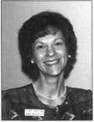

Greg Perry has been in the locksmith industry for 18 years. He's spent half that time as a field technician for the Security Engineering in Ridgecrest, Calif. Greg's also a past president of Desert Counties Chapter of the California Locksmiths Association.

**Keynotes  
Advertisers Index**

|  |  |
| --- | --- |
| Advertisers | Page |
| ALOA 2001 | 43 |
| HID | BC |
| KSP | 31 |
| Marray Enterprises, Inc. | 22 |
| MLA of New Jersey | 17 |
| MasterLink Security Products | 24 |
| Security Resources INc. | 18 |
| SAFETECH 2001 | 1 |
| Safe Tech Reference Manual | 13 |
| Security Lock Company | 9 |
| Stam Insight | IFC |
| Stone & Berg | 17 |
| Texas Locksmiths Association | 32 |
| Turn 10 | 16 |

begin with one.

to begin a new C3T60r in locksmithing,

develop a new business strategy, or advance your skills in lock technology

there's only OPIG place you need to go.



ALOA 2001

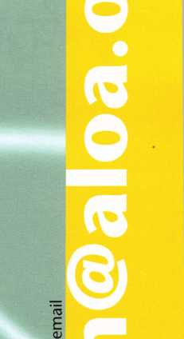

CM

VO

vn

<N

<N

**m**

vo

•

o

o

00

become one with your industry july 15-22

at baltimore convention center baltimore, maryland

fS

u

c

o

*4->

(V

E

£

a>

s—

o

E

December 2000

Keynotes

k

*mm*



The Past and the Future

Discover the history of Baltimore while attending ALOA 2001

ALOA 2001 will be held at the Baltimore Convention Center, July 15-22, 2001, in Baltimore Maryland, the perfect city to learn about new products, new technology and a part of American History.

Baltimore First Facts

1. First Post Office System
2. First umbrella used

1784 First hot air balloon ascension-by Edward Warren, in the vicinity of the area now called Mt. Vernon Place

1800 First investment banking house-founded by Alexander Brown

1. First printing of the Star Spangled Banner-Samuel Sands
2. First formal monument to George Washington-located in Mt. Vernon Place
3. First existing makers of silverware-Samuel Kirk Company (still in business)
4. First U.S. manufacturer of gas-Rembrandt Peale

1830 First national nominating convention for President of the U.S.

1839 First dental college in the world-Baltimore College of Dental Surgery

1859 First Y.M.C.A.-Pierce and Schroeder Streets

1892 First bottle cap manufacturing-invented by William Painter

1895 First electric railway locomotive in the world- B & O Railroad

1897 First country day school-now called Gilman Country School

1901 First woman professor at a medical school-Dr. Florence Rena Sabin, Johns Hopkins School of Medicine

1928 First traffic actuated traffic signal in the world

Plan now to attend ALOA 2001 in Baltimore and see the many great things this city has to offer.

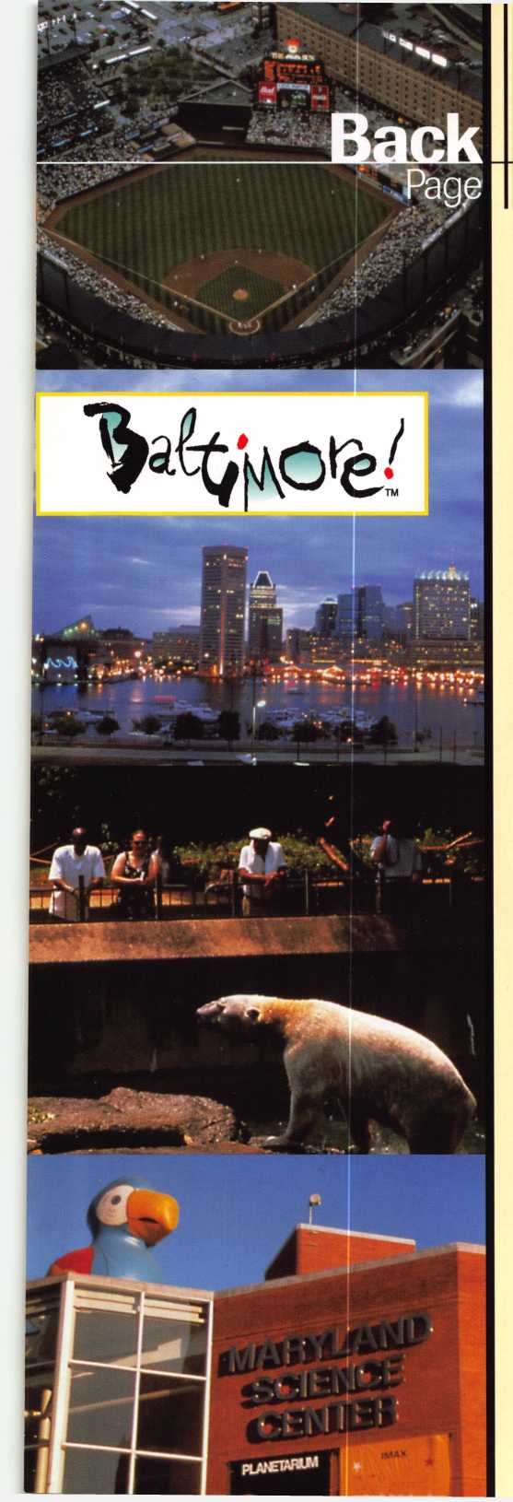

Keynotes

NEEDS YOUR HELP!!!

Authors Wanted

Share your Knowledge and experience with others in the field by writing both technical and non-technical features for upcoming issues of Keynotes.

We will send you $$$$$$ for your contribution!*

For more information on Editorial Guidelines Payment Criteria contact Patanya Johnson, Managing Editor at (214) 827-1701 Ext. 27 send an e-mail to [keynotes@anet-dfw.coi](mailto:keynotes@anet-dfw.coi)

Keynotes

3003 Live Oak Street Dallas, TX 75204 (214)827-1701 (214)827-1810 fax

* Amount is based on length of text and number

* *^0*\*\*

photos included.

■

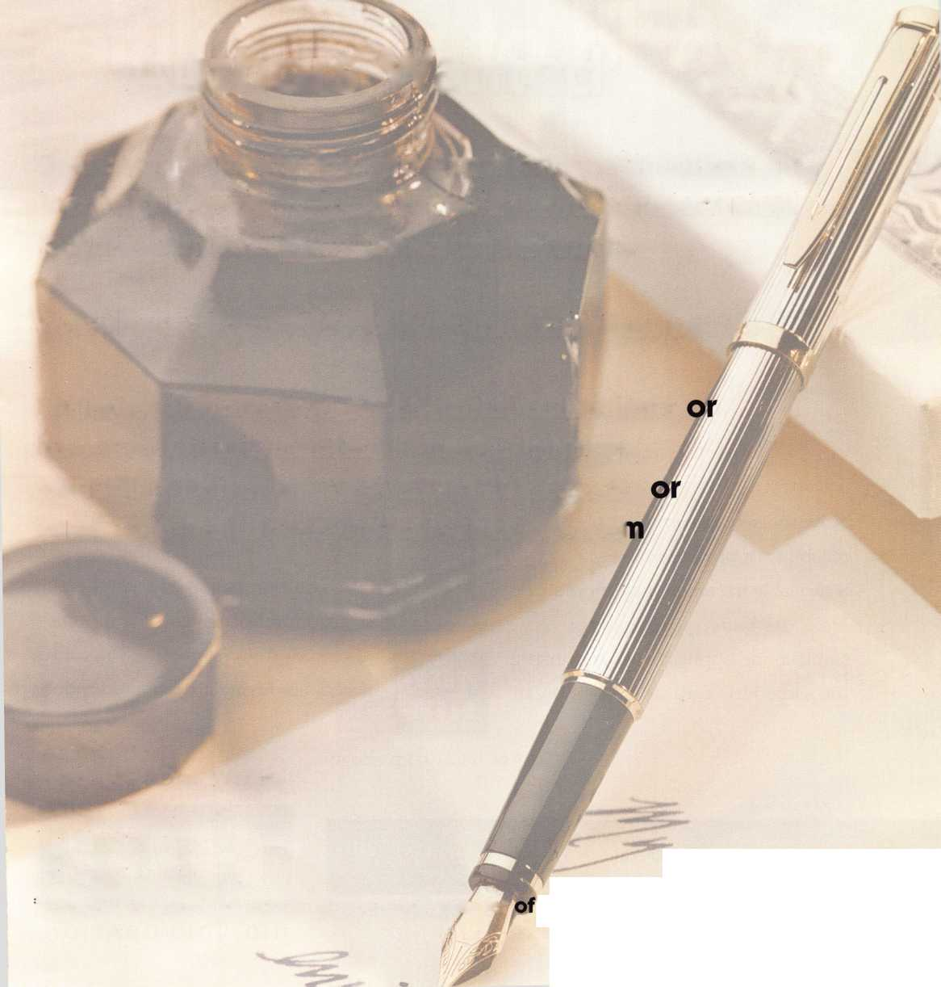

/

eProx™

Lock technology available from:

Alarm Lock

ISOProx®!!

**opens**

Introducing the ePROX™Lock Module f~ only from HID.

Now the security and reliability of proximity access is available in standard electronic locks. It’s battery-powered for stand-alone applications, and, using the same HID card or key fob, it can

Cypress I Computer I Systems

llco Unican

® Locknetics

easily augment an  
existing on-line access  
control system. With  
HID battery-powered  
proximity, the one card

solution becomes a simple and  
economical reality. The ePROX™  
Lock Module from HID. Proximity  
access has finally arrived at your door.

[www.hidcorp.com](http://www.hidcorp.com)

Copyright 1999 HID Corporation

We identify with your business. #



(8 0 0)

2 3 7

P R 0 X

(7 7 6 9)

HID **CORPORATION**

